**COLLEGE OF ENGINEERING**

**PUNE**



REPORT

ON

# “SQL INJECTION”

**INFORMATION SECURITY**

**Department of computer science and information technology**

**SUBMITTED BY**

**Name MIS No.**

Mr. Jayesh V Jawade 121942010

Mr. Mahefuj J Samadhan 121942009

**Under the Guidance of**

## DR. V. K. PACHGHARE

**Year**

**2019-2020**

## INDEX

**Sr. No. Title Page No.**

### **01 SQL Injection**

1.1. Introduction………………..……………….…………………………... 4

1.2.Vulnerable Websites..…………………………………………………... 4

1.3.Not Vulnerable Websites..………………….…………………………... 4

1.4.Identification of Vulnerable Websites……..…………………………... 5

1.5.Vulnerable Databases.…………………………………………………... 5

1.6.Tools for SQL Injection.………………………………………………... 5

### **02 Attacking SQL Server**

2.1 SQL Injection Working.…...…………………………………….…............ 6

2.2Examples………………………………………………….....…………… 6

### **03 Sniffing**

3.1 Introduction……………………………………………………………. 15

3.2What can be sniffed? …………………………………………………... 15

3.3 Working………………………………………………………………... 15

3.4 Types of sniffing………………………………………………………. 16

### **04 Finding Application Files**

4.1Finding the Application Configuration Files Using Brute Force …….... 18

4.2Working ………………………………………………………………... 18

4.3Examples ……………………………………………………………….. 19

4.4Testing for Special Vulnerability ………………………………………. 20

### **05 Input Validation Attack**

5.1Introduction…………………………………………….………………... 22

5.2Examples………………………………………………………………… 22

### **06 Preventive Measures for SQL Injection**

6.1Preventive Measures……………………………………………………. 26

6.2Preventive Techniques………………………………………………….. 26

**07 Web Application Hacking**

7.1 Parameter tampering …………………………………………………….. 30

7.2 Cross-Site Scripting (XSS) ……………………………………………… 30

7.3 Cookie Poisoning and cookie parameter tampering …………………….. 31

7.4 Directory traversals………………………………………………………. 31

7.5 Session Hijacking ………………………………………………………... 31

**08 Web Application Threats**

8.1 Injection …………………………………………………………………... 32

8.2 Insecure direct object references ………………………………………….. 32

8.3 Back door attack …………………………………………………………... 32

8.4 Man in the middle attack ………………………………………………….. 33

8.5 Phishing attack …………………………………………………………….. 33

8.6 Remote file inclusion ……………………………………………………… 33

**09 Cross Site Scripting (XSS)**

9.1 Introduction ………………………………………………………………... 34

9.2 Types of XSS Attacks ……………………………………………………... 34

9.3 Examples …………………………………………………………………... 35

**10 XSS Flaws**

10.1 Introduction ……………………………………………………………….. 43

**11 Countermeasures**

11.1 Escaping …………………………………………………………………… 44

11.2 Validating Input …………………………………………………………… 44

11.3 Sanitizing ………………………………………………………………….. 45

**12 Conclusion**……………………………………………………………………........ 46

**13 References**……………………………………………………………………......... 47

**SQL Injection**

* 1. **Introduction**

SQL Injection is an attack that injects some malicious query into the input field of the website which in turn either comment out the next queries or is true always which gives access to the attackers without credentials. It takes benefits of the planning vulnerability in poorly designed websites to take advantage of SQL statements to run malicious SQL code. In today’s world SQL Injection is very dangerous to the data integrity and also to data confidentiality. This is terms are very important to the users.

In simple words, SQL injection is an attack in which the SQL code is directly inserted into web application that are passed to SQL server for execution as well as parsing. Any procedure that constructs SQL statements might doubtless be vulnerable because the various nature of SQL and therefore the strategies accessible for constructing it offer a wealth of writing choices. The first type of SQL injection is direct insertion of code into input field which in turn combines with the SQL statements at backend. Second type of SQL injection injects malicious code into strings as data. Once the strings gets concatenated into a dynamic SQL command, the malicious code is dead.

There are mainly two different types of SQL Injection. They are as follows:-

1. Form Injection
2. URL Injection
   1. **Vulnerable Websites**

A website in which the user inputs are not properly validating and is passed directly in the query which is to be executed to obtain the result. Because of this nature of execution, hacker may give any type of user input and hence the hacker is able to execute the desired query. The one and only one reason to SQL Injection on many websites is user’s input is not properly validated at the backend and is directly passed to the dynamic SQL statements.

* 1. **Not Vulnerable Websites**

Websites which uses the bind variables are not vulnerable to SQL Injection as the Oracle database will use the bind values and does not check the content of the variables. JDBC and PL/SQL allows the bind variables. Bind variables are exclusively used to increase the security as well as performance of the websites.

* 1. **How to identify the website is vulnerable to or not?**

We can check that the website is vulnerable to sql injection by just adding single quote (‘) after the URL of the website that we want to check. If that website is vulnerable to SQL Injection then after adding the single quote it will show some error regarding php error, sql database version or sql query error.

* 1. **Which Databases are vulnerable?**

|  |  |
| --- | --- |
| Vulnerable Databases | Not Vulnerable Database |
| MySQL | Oracle |
| SQL Server |
| PostgreSQL  IBM DB2 |

* 1. **Tools Used For SQL Injection →**

1. SQLMap
2. DVWA
3. WebGoat
4. jSQL Injection
5. BBQSQL
6. NoSQLMap
7. Whitewidow

**Working**

* 1. **SQL Injection Working**

The concepts behind a SQL Injection Attack are very easy and these types of attacks are very simple to execute. To find a SQL injection flaws, the attacker must find an arguments that the websites passes to the back-end database. By planting malicious SQL queries into the content of an arguments, the hacker can trick the websites by inserting a malicious query to the database. SQL Injection attack is more understandable by practical rather than theory.

* 1. **Examples**

1. **SQL Injection on website to retrieve the data using SQLMap :-**

Here, we will try to retrieve the data of the website with the help of SQLMap in kali Linux.

**Step 1:-**sqlmap–h

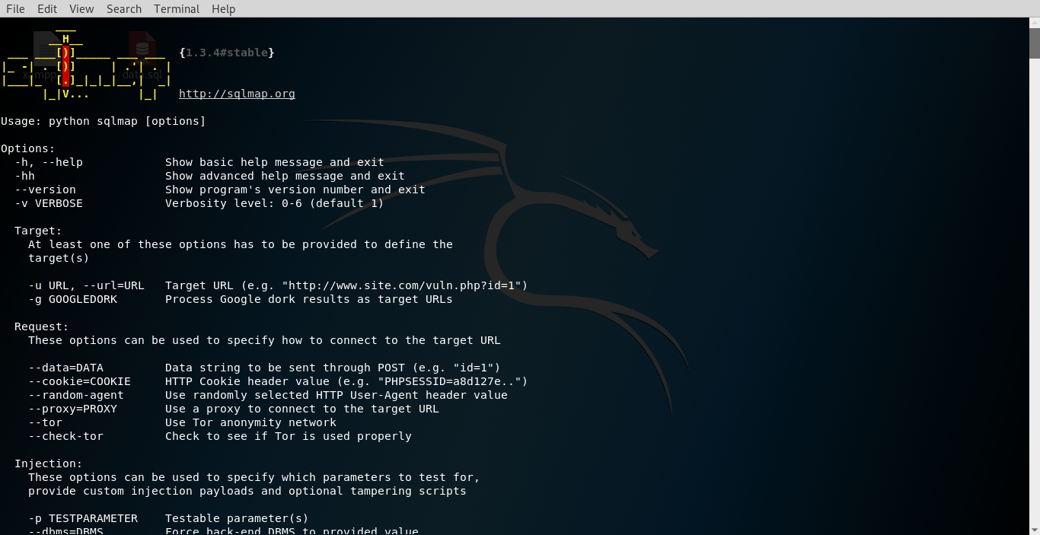

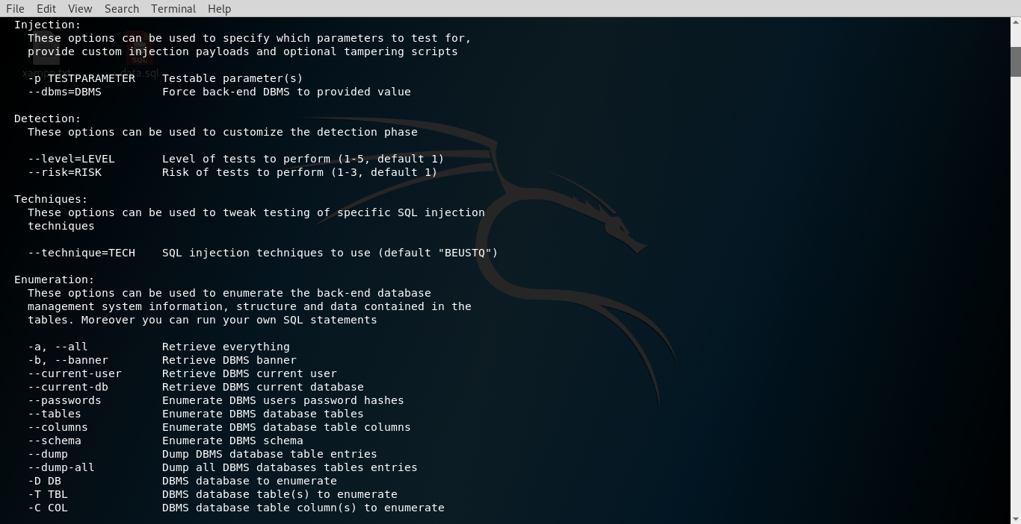

**Step 2:-**sqlmap -u https://ssy.org/details.php?id=1 –dbs

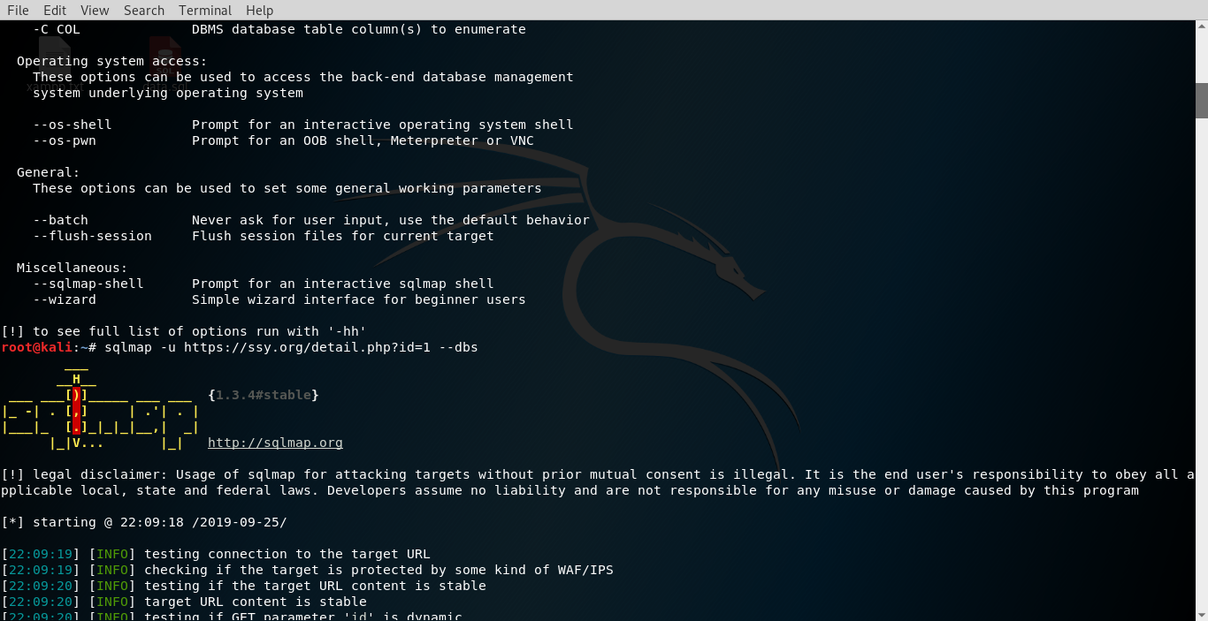

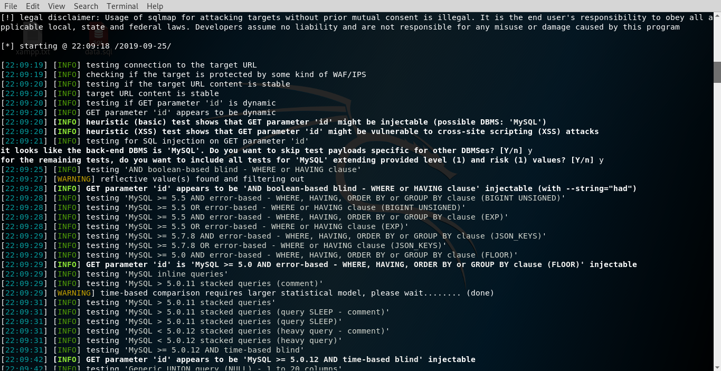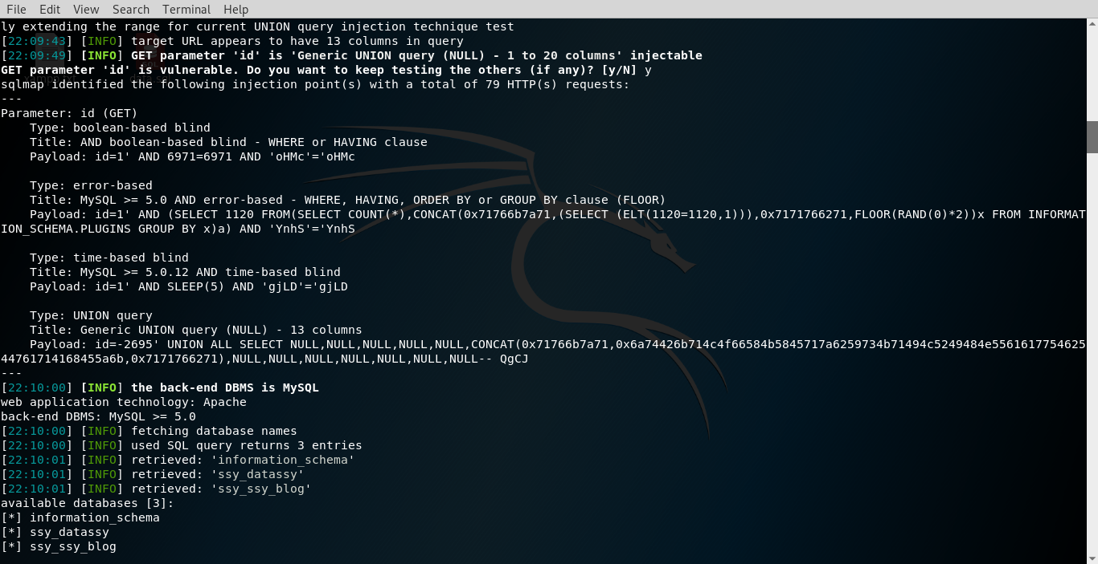

**Step 3:-**sqlmap -u https://ssy.org/details.php?id=1 -D ssy_datassy–tables

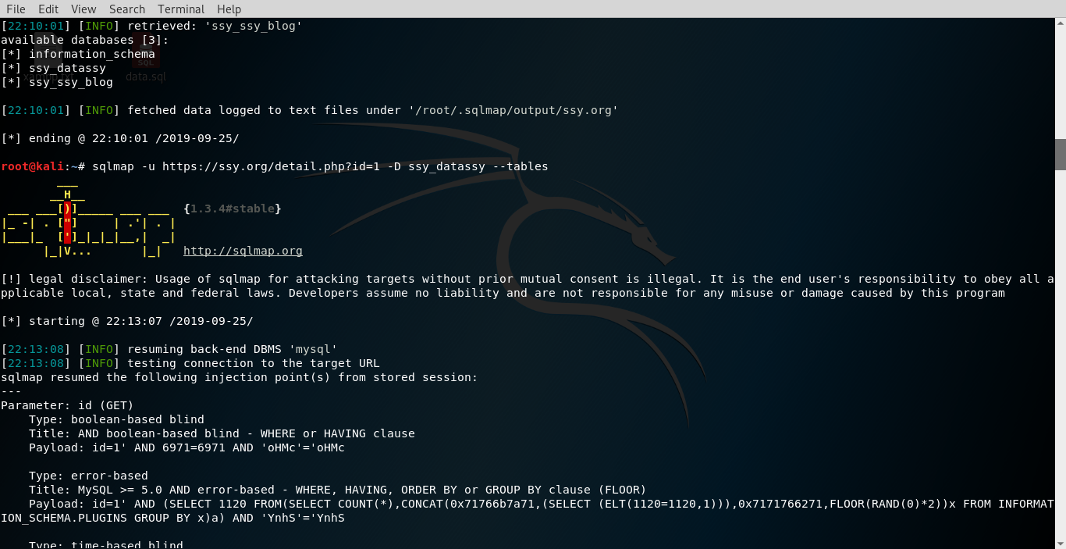

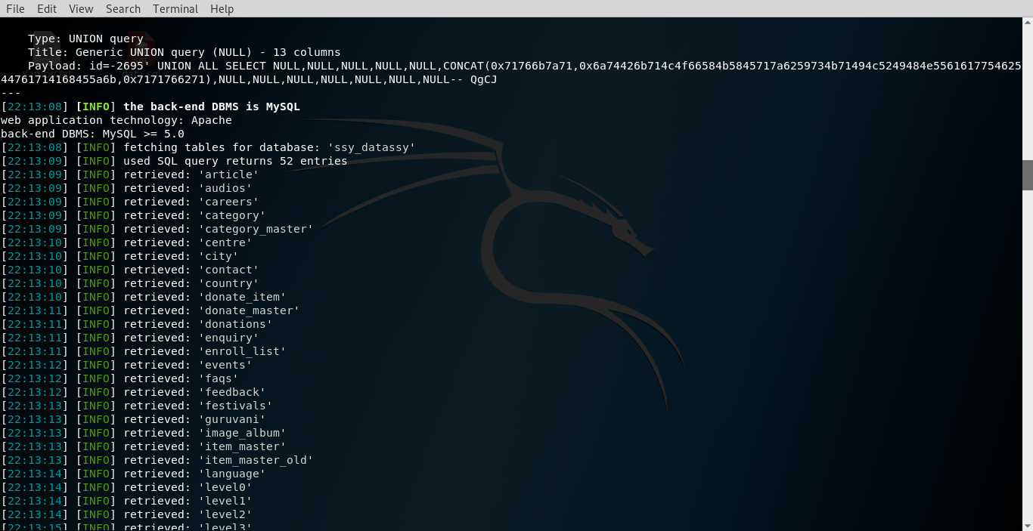

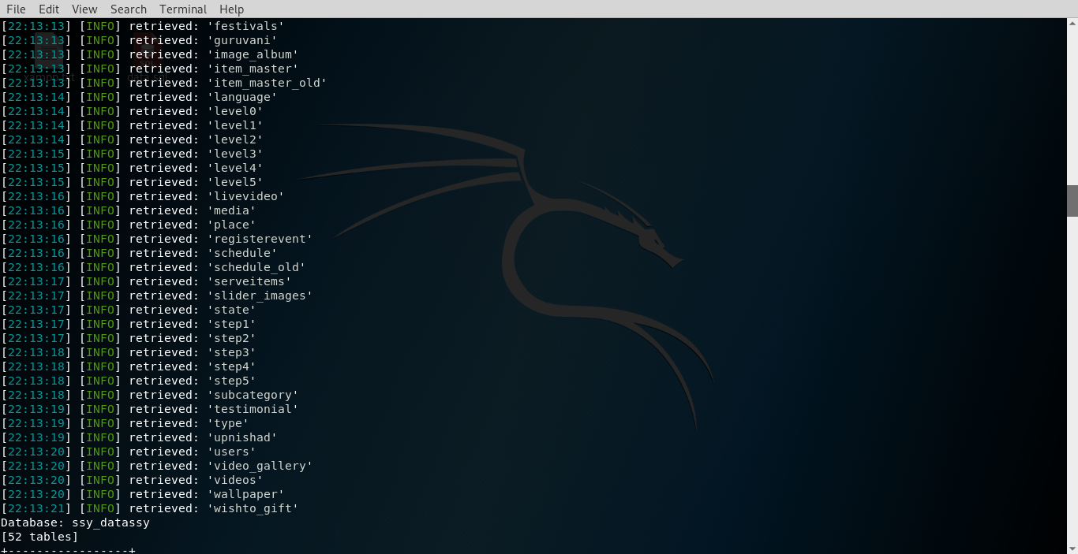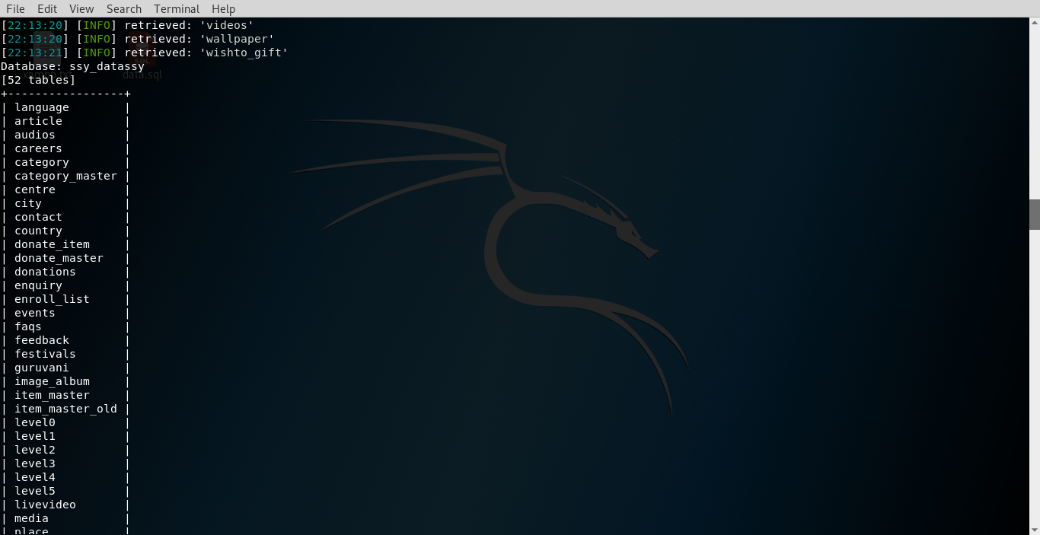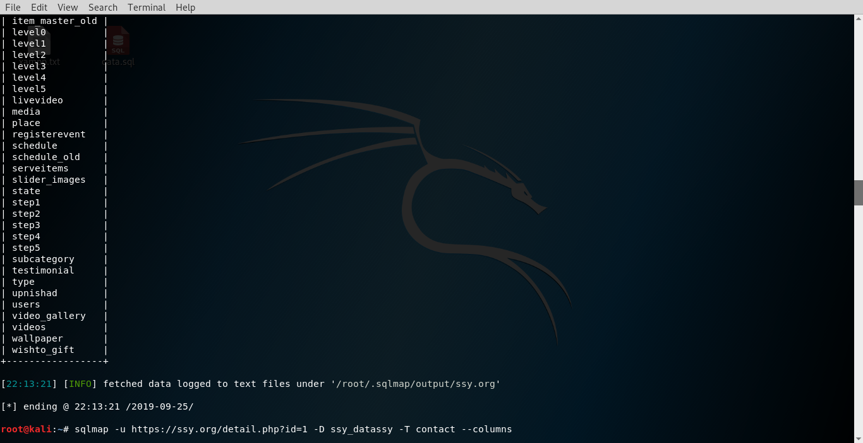

**Step 4:-**sqlmap -u https://ssy.org/details.php?id=1 -D ssy_datassy -T contact –columns

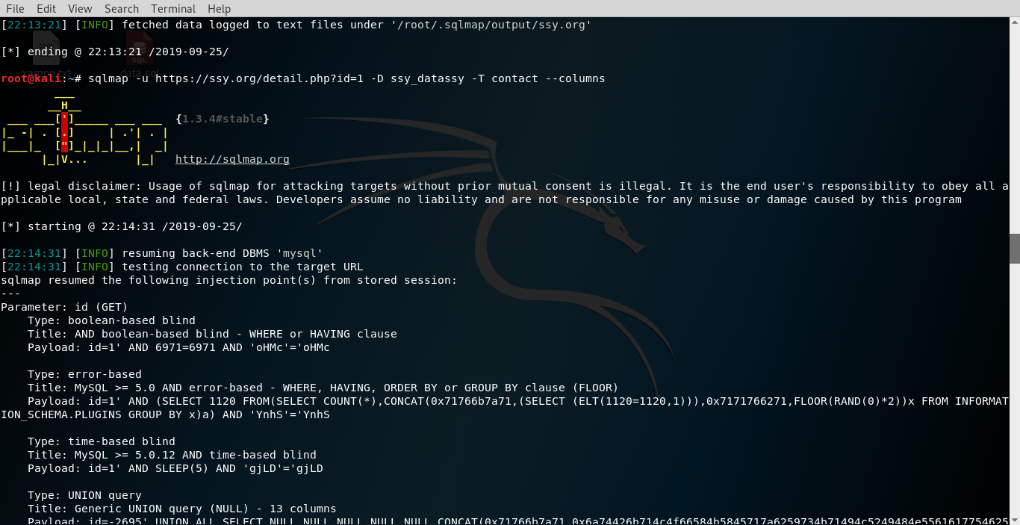

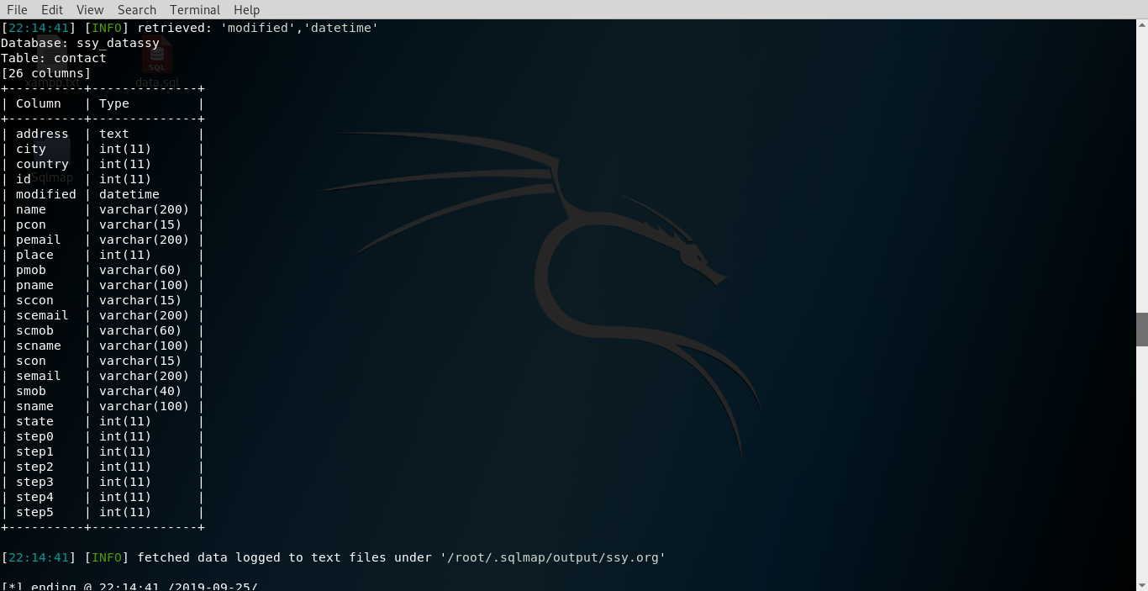

**Step 5:-**sqlmap -u https://ssy.org/details.php?id=1 -D ssy_datassy -T contact -C smob–dump

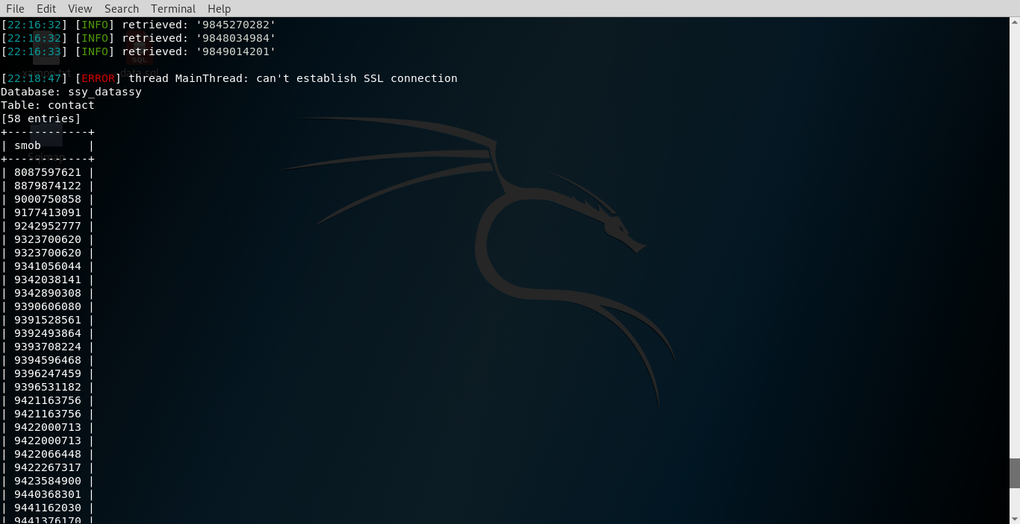

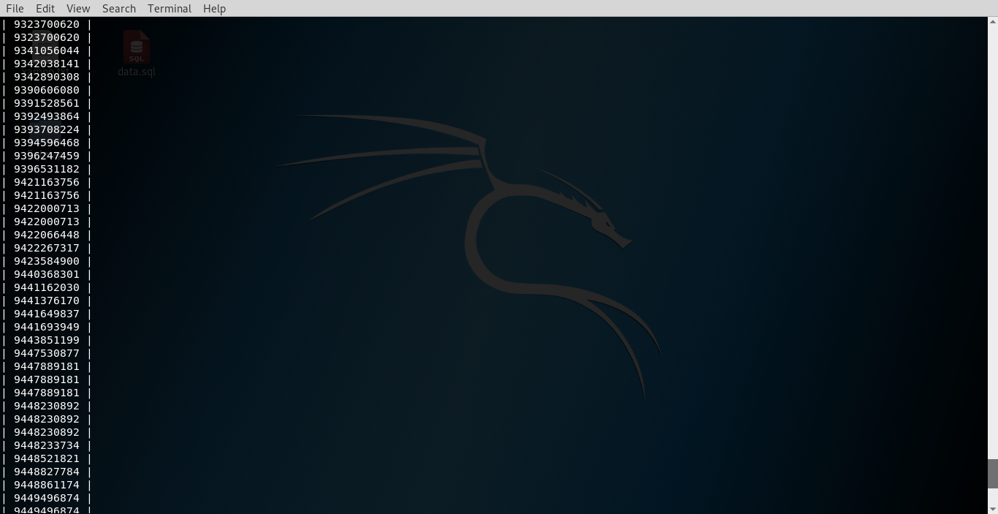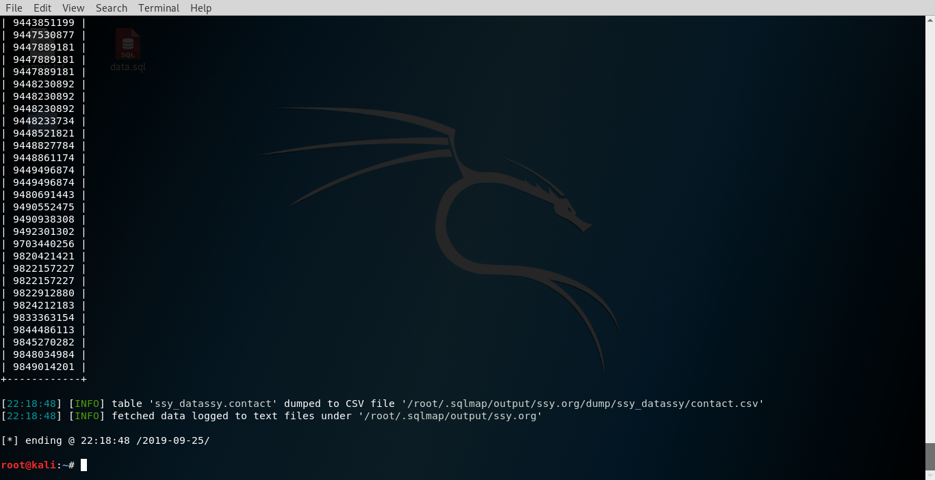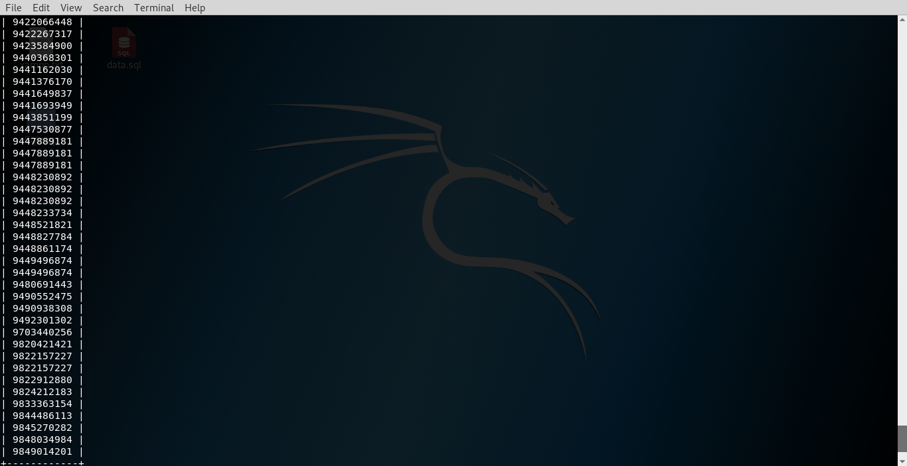

Hence, we successfully retrieved the database of the website.

**Sniffing**

**3.1 Introduction**

Process of monitoring as well as capturing all of data packets in a particular network using some sniffers are called as sniffing.

If any port is open on the target system then hacker can sniff the complete traffic of that network. Any number of users which are connected to the same network may be sniffed by the hackers.

Sniffing allows the hackers to see all the traffic within the network even if the traffic is protected or unprotected. Sniffing is mainly used to gather the information about the victim and also perform the further attacks based on this information’s.

### **3.2 What can be sniffed?**

The following type of data may be sniffed by hacker:-

* Email traffic
* Router configuration
* FTP passwords
* DNS traffic
* Telnet passwords
* Web traffics
* Chat sessions

### **3.3 Working**

A sniffing tool actually turns the NIC card of the victim’s system to the **promiscuous mode** so that it listens to all of the data in terms of packets transmitted.

Promiscuous mode refers to the distinctive method of local area network (LAN), specifically, network interface cards (NICs), that enables associated NIC to receive all traffic on the network, even if it not addressed to this NIC.

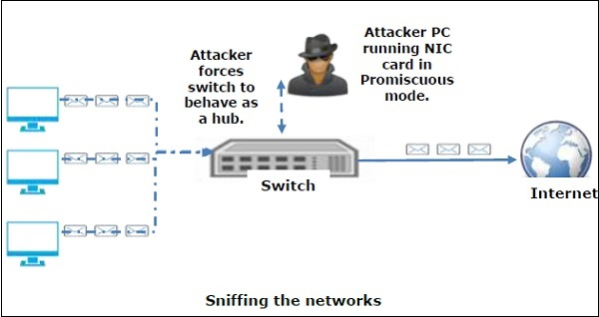

Fig 3.1.a Network Sniffing

A sniffing tool can continuously monitor all the traffic in a particular network through the NIC card by decoding the information from encapsulated data packets.

### **3.4 Various Types of Sniffing**

There are mainly two types of sniffing. They are as follows:-

### **Passive Sniffing**

In passive sniffing, the traffic is captured fastened however it's not altered in any approach. Passive sniffing permits only listening. It works with Hub devices only not on switches. On a hub device, the traffic is broadcasted to all the ports. In a network that uses hubs to for connection, all hosts on the network will see the traffic. Therefore, an attacker can easily capture traffic in that network.

Now-a-days the use of hubs are significantly reduced and instead of hubs the switches are used. Switches are more intelligent than hubs. Hence, passive sniffing is not effective now-a-days.

### **Active Sniffing**

In active sniffing, the data packets should even be altered in any way as determined by the attack. Active sniffing is used to sniff a switch-based network.

Active Sniffing Techniques are as follows −

* ARP Poisoning
* Media Access Control Flooding
* DNS Poisoning
* Dynamic Host Configuration Protocol Attacks
* Spoofing Attacks

**Finding Application Files**

**4.1 Finding the Application Configuration Files Using Brute Force**

There are various tools for finding the application configuration files using brute force. Here we will be seeing the tool named as “DIRB”.DIRB is also known as the web content scanner.DIRB is a terminal based tool to brute force any directory of the website based on the wordlist.DIRB makes an HTTP request and see the HTTP response code of every request. And the most important thing about DIRB is it is open source tool. Hence anyone can use it freely.

**4.2 Working**

Working of the DIRB is totally based on the wordlist file. A wordlist contains around 4000 word for brute force attacks. Any wordlist can be used for this tool according to the users wish. There are so many updated wordlist which are freely available on the internet.DIRB searches for the keywords in its wordlist in each object of a web site or a server or directory. It may be an admin panel or a directory that's liable to attack. The secret is to search out the objects as they're typically hidden.

Main aim of DIRB is to assist in skilled auditing in security testing. DIRB appearance for pretty much all the net objects that different generic CGI scanners can’t search for. It doesn’t search for vulnerabilities however it's only for the net contents that may be vulnerable.

**Step 1:- Directly Search for the DIRB in Kali Linux**

**Step 2:- Start Dirb**

Open the terminal and type DIRB to get the help screen.

**Step 3:-Execution**

Just type the command **dirb** followed by the URL of the website for which we are testing.

**Step 4:- Dirb also works for hidden object scanning also**

Using Dirb’s default wordlist file it searches the URL for 4612 Object types.

**4.3 Example**

**1] Kali >dirb https://www.webscantest.com/**

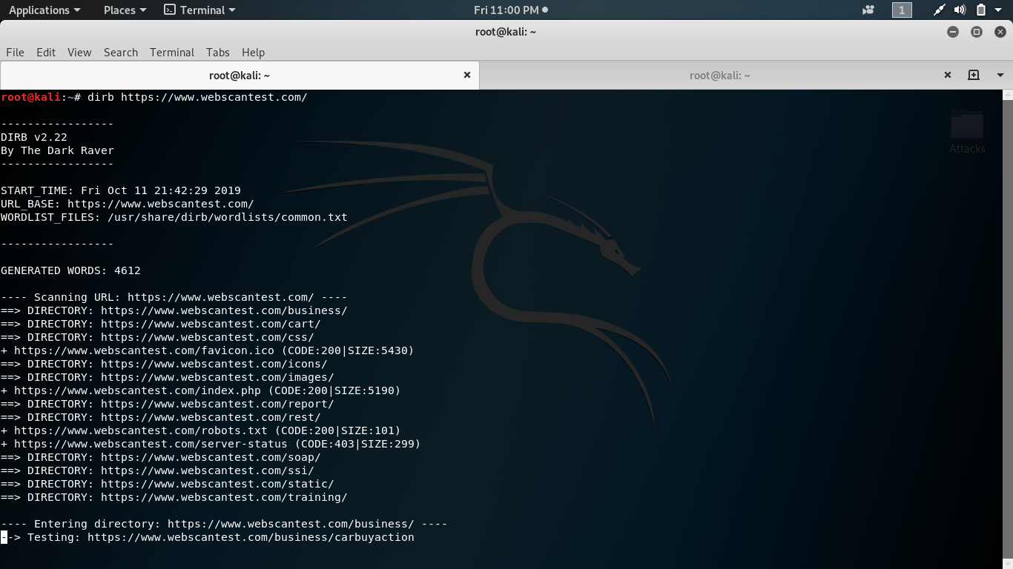

**2] Kali >dirb https://jayeshjawade.io./**

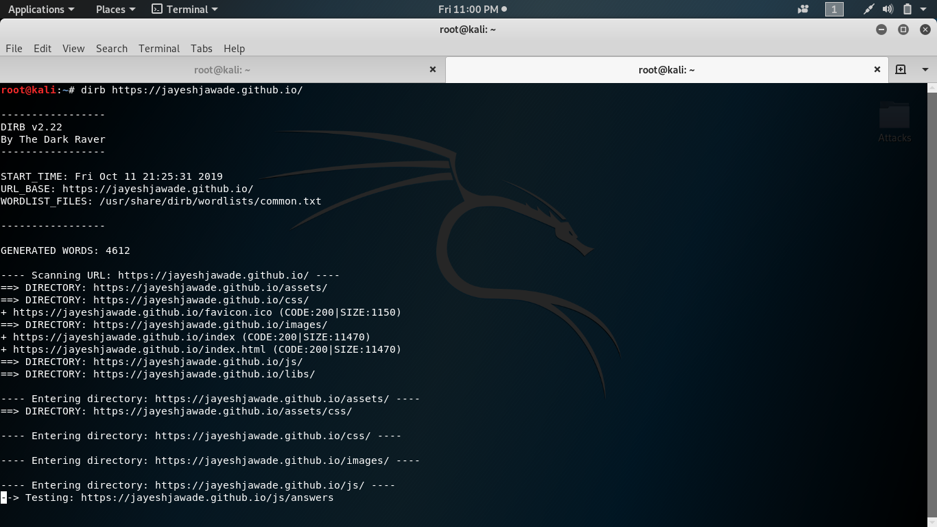

The results list with the size of the file and response code for every ping is shown as above. DIRB starts scanning the files in the particular directory whose response code is 200.It scans the whole directory with words in the wordlist and shows the result on the terminal. At last when DIRB is done with all the process, it sends the number of objects which are actually found.

**4.4 Check using Special Vulnerable list**

We may also use the DIRB tool to check for special vulnerable objects in any types of web application. Every technologies have different vulnerabilities. DIRB tool may be use for looking some specific vulnerable objects which belongs to the particular technologies.

In Kali, DIRB tool has specific wordlists which contains some vulnerable simple hidden objects. We can check this at :

**Kali > cd/usr/share/dirb/wordlists/vulns**

Then check all the files of that directory.

**Kali > ls –al**

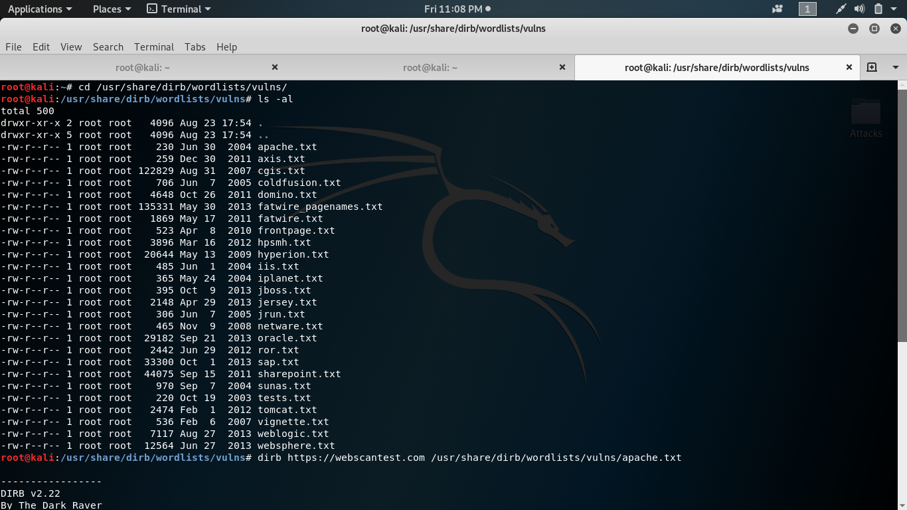

As shown above, each of the specific vulnerability contains number of file list to test.Let’s try for Apache web server and we need to take apache.txt for testing this.

To run

**Kali >dirb**[**http://webscantest.com**](http://webscantest.com)**/usr/share/dirb/wordlists/vulns/apache.txt**

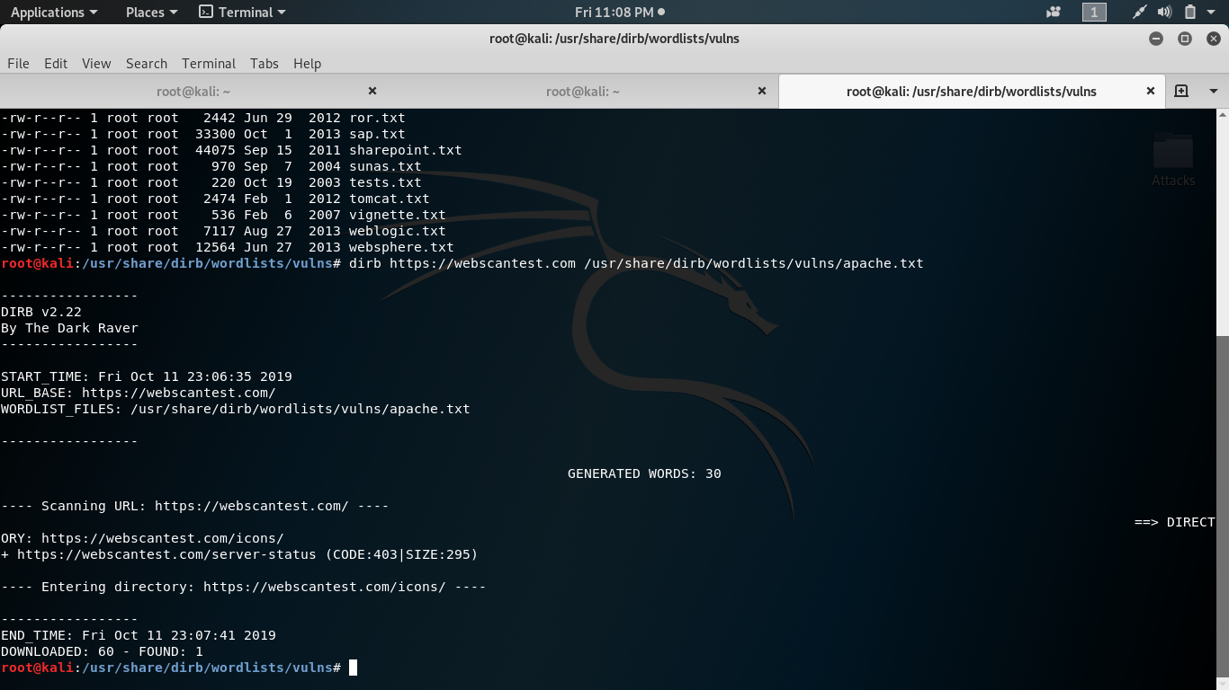

Hence, in this way we can use the DIRB tool to find out the application configuration files as well as to find the vulnerable files in the application.

**Input Validation Attack**

**5.1 Introduction**

The very common source of SQL injection is entering the malicious user input in the text field which is given directly to the SQL query as a parameter or an argument.

**5.2 Examples**

1. **SQL Injection on Login Authentication of the website :-**

Here we will be using a simple website where user has to know the credentials for entering inside the website. We will be hosting this site on apache server and uses the MySQL database with the help of XAMPP tool. Let’s try to bypass this authentication by using the SQL Injection attack.

**Step 1:-** Host the website on localhost and try to login by using some authenticated users credentials to check that all works fine.

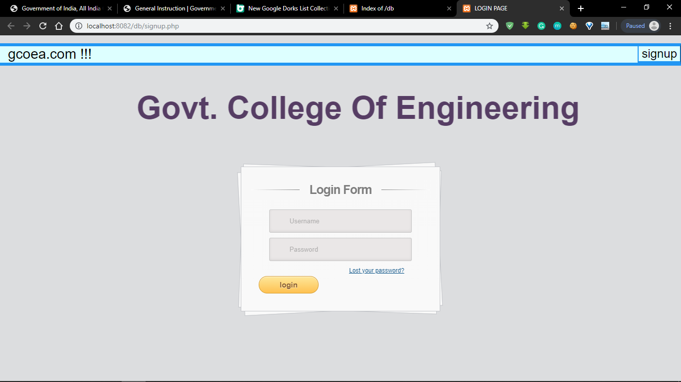

**Step 2:-** Now check that the login authentication is actually working or not properly.

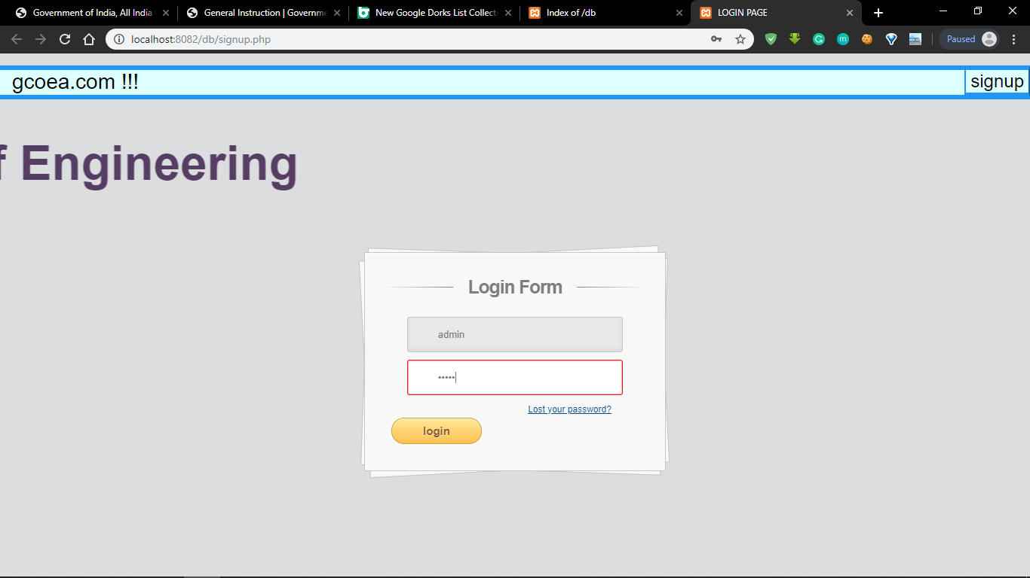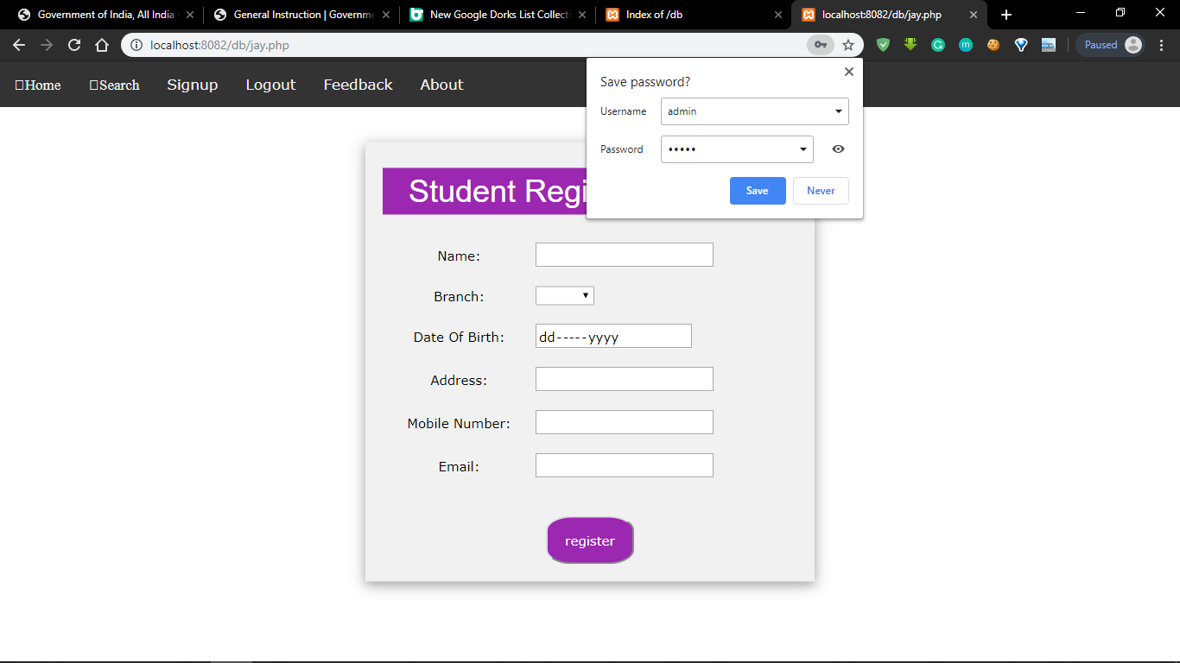

**Step 3:-** Now try to bypass this authentication by trying different sql queries.

We tried this credentials :-

Email :- xxx@xxx.xxx (mailto:xxx@xxx.xxx)' OR 1 = 1 LIMIT 1 -- ' ]

Password :- 1234(Any password)

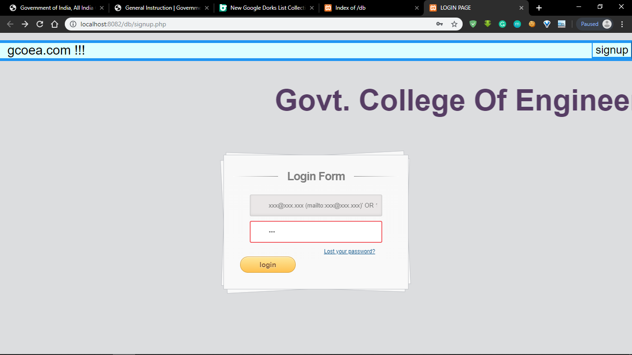

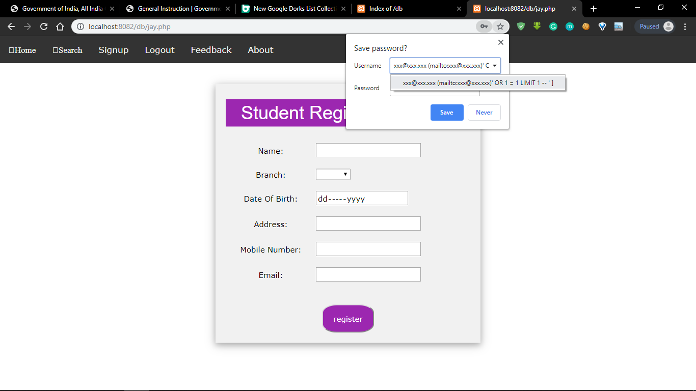

Hence we can bypass the login by using such SQL queries.

1. **SQL Injection testing Using DVWA Tool :-**

Here we will try to collect some extra information about the website by using some SQL queries.

**Step 1:-**If we put the UserID then the first name and last name of that user is shown.

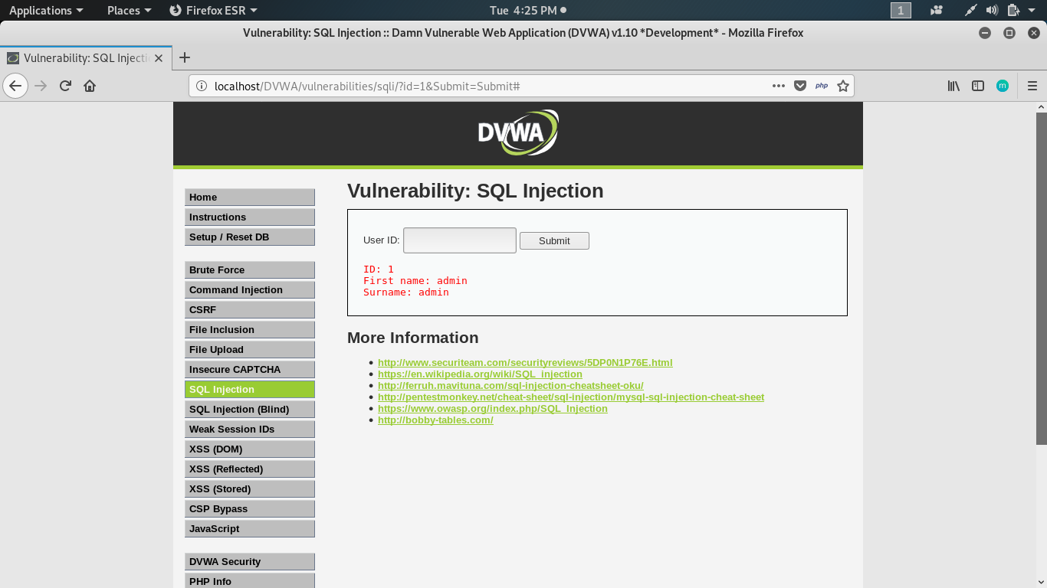

**Step 2:-** If we type **‘union select null, @@hostname #** as user input then it will give us the hostname.

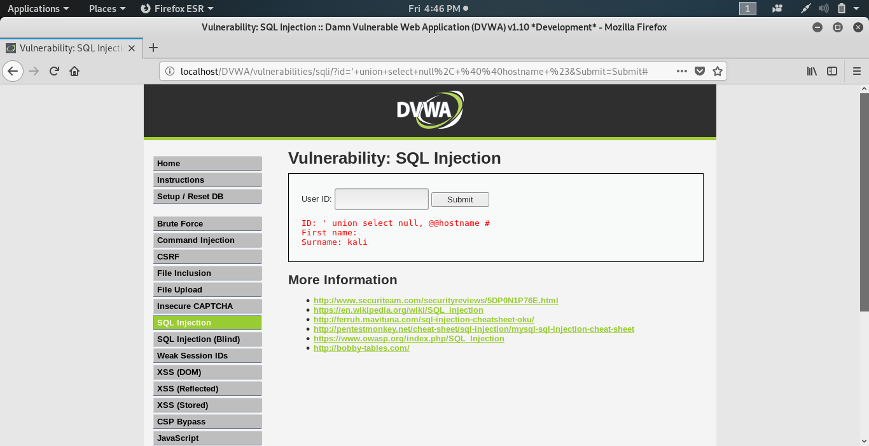

**Step 3:-** If we type **‘union select 1, @@version#** as user input then it will give us the version of the database.

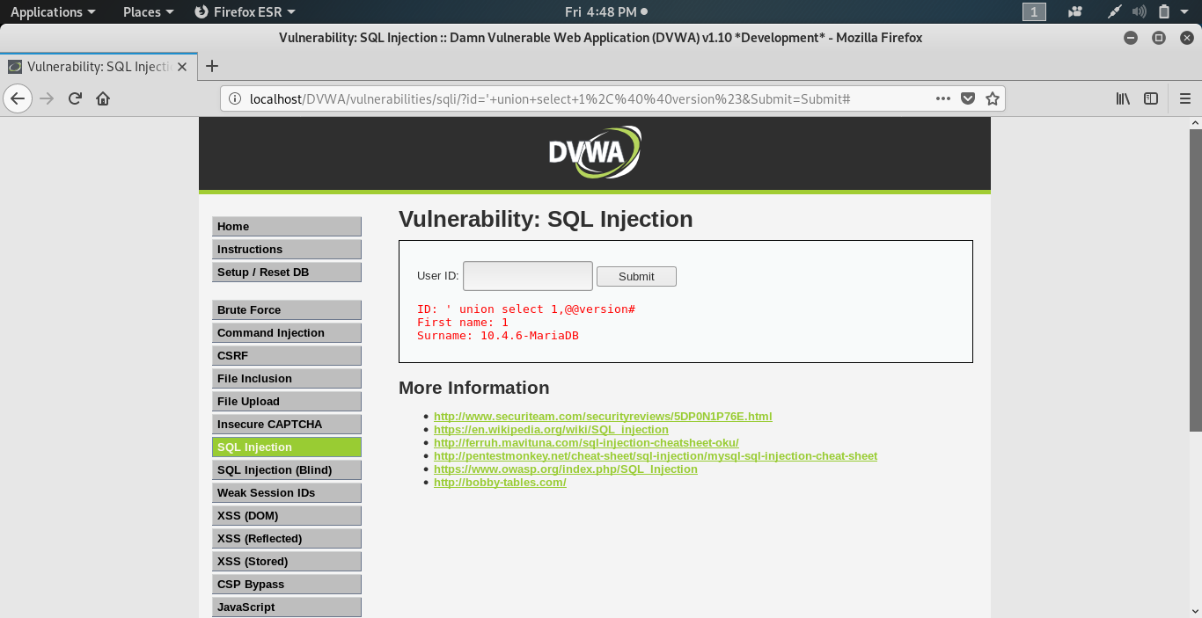

**Step 4:-** If we type **‘union select user, password from users#** as user input then it will give us the UserID and Password of all the users in the database.

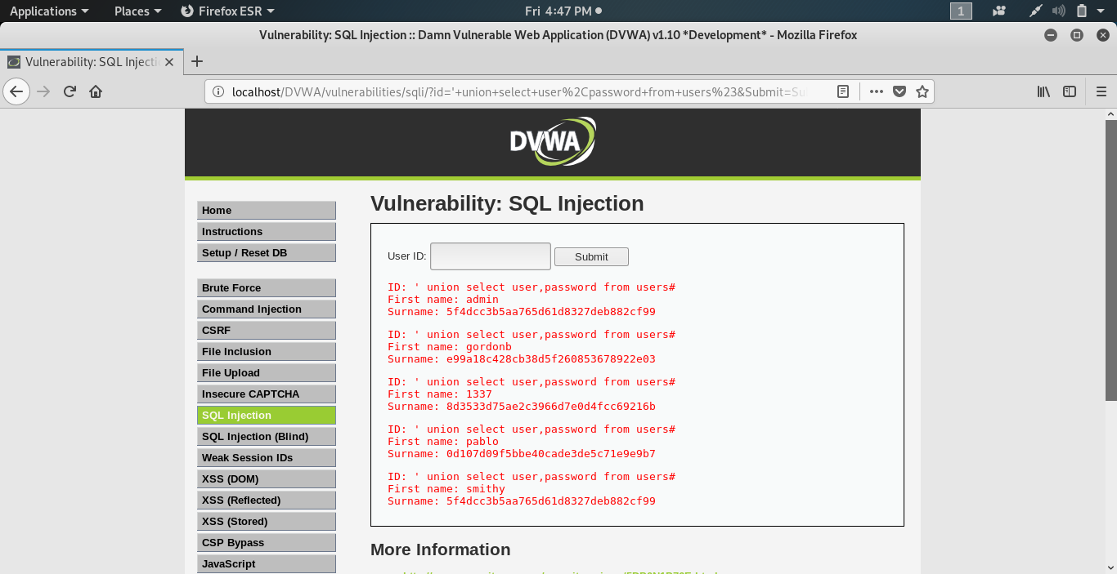

In this way we can calculate the information about any website using such SQL queries.

**Preventive Measures**

**6.1SQL Injection Prevention**

Normally SQL Injection occurs because of over privileged database logins or unfiltered user inputs. SQL Injection attacks are often simply prevented by straightforward program code changes, developers should use the subsequent ways to performance and each internet accessible procedure. Every dynamic SQL statement should be protected. One malicious SQL statement may weaken all information or whole information server.

**6.2 Prevention Techniques**

The techniques for preventing SQL Injection attacks are as follows:-

1. **Validate The Input →**

Every input should be validated before directly storing it to database or before inserting it into SQL query at the server level. Suppose the data failed to pass all the input validations then it must not be accepted and the failed status should be shown to the user. Lots of web applications use hidden fields and different techniques that additionally should be valid. Suppose if a bind variable is not getting used, special information characters must be removed.

1. **Using Bind Variable →**

Bind Variable is the most important and probably the most powerful protection against SQL Injection attack. By using bind variable we will improve performance as well as efficiency of the application. Application coding standards must need the utilization of bind variables in every statements. None of the SQL statements must be formed by adding along passed parameters and strings. Bind variables must be used for each SQL statement.

1. **Limit The Input Field By Applying Some Constraint →**

Limit the user input field if possible such as giving the accurate maximum length of text boxes or by accepting only the numerical password instead of alphabetical password. So that the attacker or hacker may not be able to write the query inside the box. We can also apply some constraints such as limiting the length of the text box to some specific characters.

1. **Verify the type of data which is passed by user →**

Verify the data types of the user inputs before passing it into a SQL statement. For string data replace single quotes (‘) with two single quotes (‘’) using the replace function or any other functions.

Example: - New_Str =replace (user input,’,’’)

1. **Stored Procedures →**

By using stored procedures we can avoid direct access to the tables in the database. A stored procedure is a prepared SQL code or statement that you can save, so that the same code can be reused whenever needed.

1. **Updates →**

Vulnerabilities in web applications, databases and websites that attacker can exploit using SQL injection are regularly discovered, so it's important to fix it and updates as early as possible. Patch management is very much important to protect the web applications.

1. **Firewall →**

To protect from web attacks there are so many types of web application firewalls (WAF) which are either a software or an appliance based which helps to filter out the malicious data. Some well known web application firewalls allowed the admin to add the new rules whenever necessary. A WAF are often notably helpful to supply protection against a new vulnerability before a patch is found.

Ex: - ModSecurity, nginx web server, Microsoft IIS, etc.

1. **Give Least privileges →**

Always use the least privileges to do any type of work to do it completely which in turn limits the hackers or attackers and it is always safe.

1. **Delete the Unnecessary functionality →**

Delete all the unnecessary functionalities of the database that you think an attacker can take advantage of and it in turn reduces the attack surface area.

1. **Precise the information on webpage →**

Don’t show more information on the webpages than required.Beacuse hackers can learn much more than expected about the database from the error message shown.

**Web Application Hacking**

Web application gives an interface between web server and client to communicate. Web pages are generated at the server side, and web browsers helps to present them at the client side. The data is exchanged between client and server in the form of HTML pages through HTTP protocol.

There areserver-side vulnerabilitiesand clientside vulnerabilities which lead to a web application attack.

**Attacks:**

* Parameter tampering
* Cookie Poisoning and cookie parameter tampering
* Session Hijacking
* Cross-Site Scripting (XSS)
* Directory traversals

**7.1 Parameter tampering**

Parameter tampering is a form of attack in which certain parameters in the form field of Web pagedata entered by a user are changed withoutuser's authorization. This points the [browser](https://searchwindevelopment.techtarget.com/definition/browser) to apage, linkor site other than the one the user intends.

**7.2 Cookie Poisoning and cookie parameter tampering**

Cookie poisoning is the[cookie](https://searchsoftwarequality.techtarget.com/definition/cookie) modification. To gain unauthorized information about the user for [identity theft](https://searchsecurity.techtarget.com/definition/identity-theft). The attacker can use the information to open new accounts or to gain access to the user's existing accounts.

Cookies which are stored on your computer's hard drive maintain bits of information that allow Web sites you visit to speed up your transactions,authenticate your identity, personalize their presentations for youand monitor your behaviour. Cookies can be accessed by persons unauthorized to do so. Unless security methods are in place, an attacker can inspect a cookie to determine its purpose and edit it so that it helps them get user information from the Web site that sent the cookie.

**7.3 Session Hijacking**

The Session Hijacking attack consists of the manipulation of the web session control mechanism, which is generally managed for a session token.

Since http communication uses many different TCP connections, the web server needs a technique to recognize every user’s connections. The most useful technique depends on a token that the Web Server sends to the client browser after a successful client authentication. A session token is generally composed of a string of variable width and it could be used in different ways, in the header of the http requisition as a cookie,like in the URL, in other parts of the header of the http request, or yet in the body of the http requisition. The Session Hijacking attack compromises the session token by predictingor stealing a valid session token to gain unauthorized access to the Web Server.

**7.4 Cross-Site Scripting (XSS)**

Cross-site scripting is a web security vulnerability that permits an attacker to compromise the interactions that users have with a vulnerable application. It allows an attacker to avoid the same origin policy, which is designed to isolate different websites from each other. Cross-site scripting vulnerabilities normally allow an attacker to trick as a victim user, to carry out any actions that the user is able to perform, and to access any of the user's data. If the victim user has limited access within the application, then the attacker may be able to gain full control over all of the application's functionality and data.

**7.5 Directory traversals**

Directory traversal is an HTTP attack which allows attackers to execute commands outside of the web server’s root directory

and gain access to restricted directories.An attacker can make use of this vulnerability to step out of the root directory and access file system. This might give the attacker the capability to view restricted files, which could provide the attacker with more information essential to further compromise the system. Depending on how the website access set up is, the attacker will execute commands by impersonating himself as the user which is associated with the website. Therefore it is all depends on what the website user has been given access to in the system

**Web Application Threats**

1. Injection
2. Insecure direct object references
3. Security misconfiguration
4. Sensitive data exposure
5. Cross site request forgery
6. Back door attack
7. Man in the middle attack
8. Phishing attack
9. Remote file inclusion

**8.1 Injection**

Injection attacks refer to a wide class of attack vectors. In an injection attack, an attacker provides untrusted input to a program. This input gets processed by interpreter as part of a command or query. In turn, this modifies the execution of that program.

**8.2 Insecure direct object references**

There can be lots of variables in the application such as “pid”,“id”,“uid”. Though these values are often seen as HTTP parameters, they can be found in headers and cookies. The attacker can access, delete or editany of other users objects by changing the values. This vulnerability is called Insecure direct object references.

.

**8.3 Back door attack**

In the field of cybersecurity, a [backdoor](https://blog.malwarebytes.com/glossary/backdoor/) refers to any technique by which authorized and unauthorized users are able to get across normal security methods and gain high level user access on a computer system, network, or software application. Once they are incybercriminals can use a backdoor to install additional malware,steal personal and financial data, and hijack devices.

**8.4 Man in the middle attack**

**A maninthemiddle attack** is a type of cyberattack where a malicious actor adds him into a conversation between two parties, satirizes both parties and gains access to information that the two sides were seeking to send to each other. A maninthemiddle attack permits a malicious actor to intercept, send and receive data meant for someone else, or not meant to be sent at all, without either outside party knowing.

**8.5 Phishing attack**

Phishing is a type of social engineering attack frequently used to steal user data, including credit card numbers andlogin credentials. It happens when an attacker, impersonating as a trusted entity, fools a victim into opening an email, text message. The recipient is then fooled into clicking a malicious link, which can lead to the installation of malware, the freezing of the system as part of a ransomware attack or the revealing of sensitive information.

**8.6 Remote file inclusion**

In order to include a remote file you have to insert a string with the url of the file to an Include function of the own language. Then the web server of the website under attack makes a request to the remote file, gets its contents and includes it on the web page serving the content. It is then managed by the parser of the language.

**8.7 Cross site request forgery**

This describes an attack against authenticated web applications using cookies. The attacker is able tofool the victim into creating a request that the victim did not intend to create. Therefore, the attacker misuses the trust that a web application has for the victims browser. While Cross-site Request Forgery attacks do not provide an attacker with the response returned from the server, a smart attacker could affect a good amount of damage, Specifically when combined with wellcrafted social engineering attack on administrative users.

**Cross Site Scripting**

**9.1Introduction**

Cross-site scripting is a type of computer security vulnerability that is found in webbased applications which allows code injection by malicious web users into any webpage that is viewed by other users.

When a malicious website could possibly load a website onto a new window and then use JavaScript towrite or readinformation on the other website.XSS is made possible due to the fact that faulty coding causes XSS holes in the client-side script that allows for insertion of malignant code. During an attack all looks good to the end user, but in reality they are subject to a wide variety of threats. These vulnerabilities are exploited by attackers to bypass access controls such as the same origin policyXSS is a potentially dangerous vulnerability that is easy to execute and very long and arduous to repair. Lots Of site owners do not consider an XSS hole to be a big threat, which is a generally made mistake because the effects of an XSS attack against web applications and its users have been shown to be extremely serious. The most common kinds of web applications that are victimized by XSS attacks are discussion boards,search engines, web-based emails, and posts.

**9.2 Types of XSS Attacks**

1. DOM-based
2. Reflected
3. Stored

**1 DOM-based.**

Document Object Model is a platform for representing HTML or XML and other related languages. In this vulnerability, the problem exists within the pages client side script. If an attacker hosts a malicious site, which contains a vulnerable website on a client’s local system, a script can be injected. Now the attacker can run the privileges of that user’s browser on their system Local Zone.

**2 Reflected vulnerability.**

It is by far the most common type of the three but is not nearly as popular as the others. If a web user provided data to a server side script to instantly generate a resulting page back to him a resulting page without html encoding can be intercepted by an invalidated user. The malicious code can then be injected. The attacker can use a little social engineering to convince a user to follow a malicious URL that will inject code into the subsequent page. After the attacker has finished that, he now has full access to that web pages content.

**3 Stored XSS**

This vulnerability is prone to the most powerful kinds of attacks. First, the data is stored on the servergiven by a web application. Then it is later reopened and shown to other users on a webpage with no any html encoding. An example of this is an online chat or message board that allows users to sign in to post messages for other users to read.The malicious scripts are capable of being provided and used more than once. This means an attacker can exploit this vulnerability and affect a large amount of users. In addition to the large number of users already at risk, this web application can also be affected by a cross-site scripting virus or worm.

**9.2Examples**

**[1] XSS (DOM) testing Using DVWA Tool :-**

The JavaScript code obtains value from the URL parameter “default” and writes the value in the webpage and as the result, the web page shows English as output. Now attacker will inject following code into URL <script>alert(“hi”);</script> and send this link to the client.

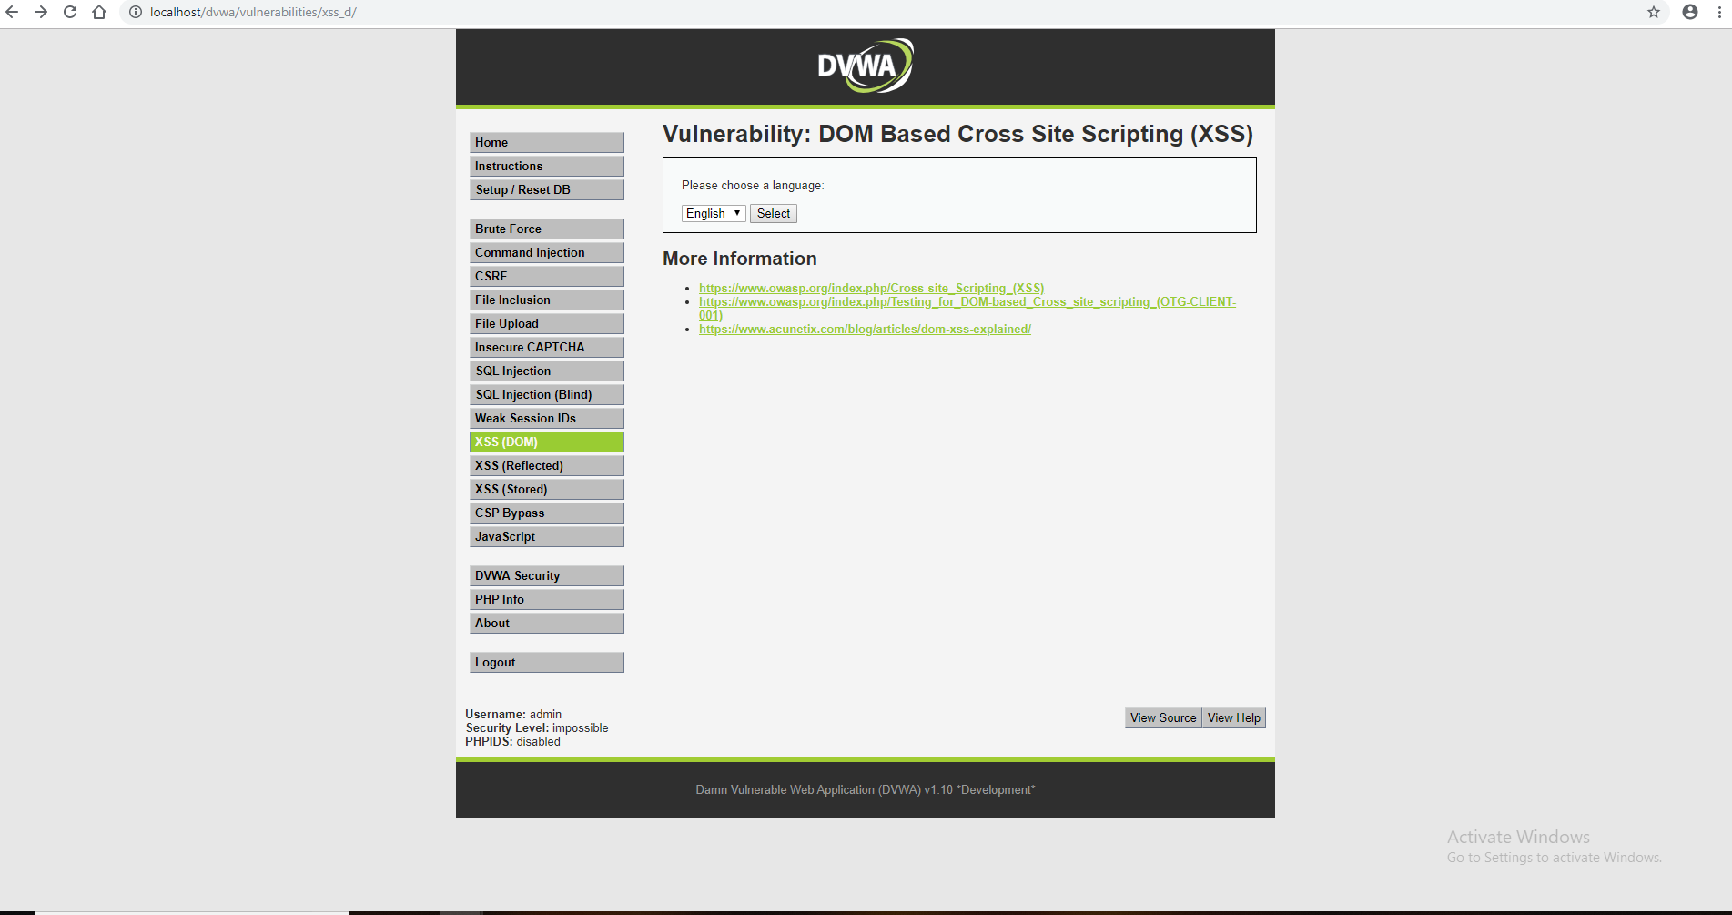

Now you can check the output in the given screenshot.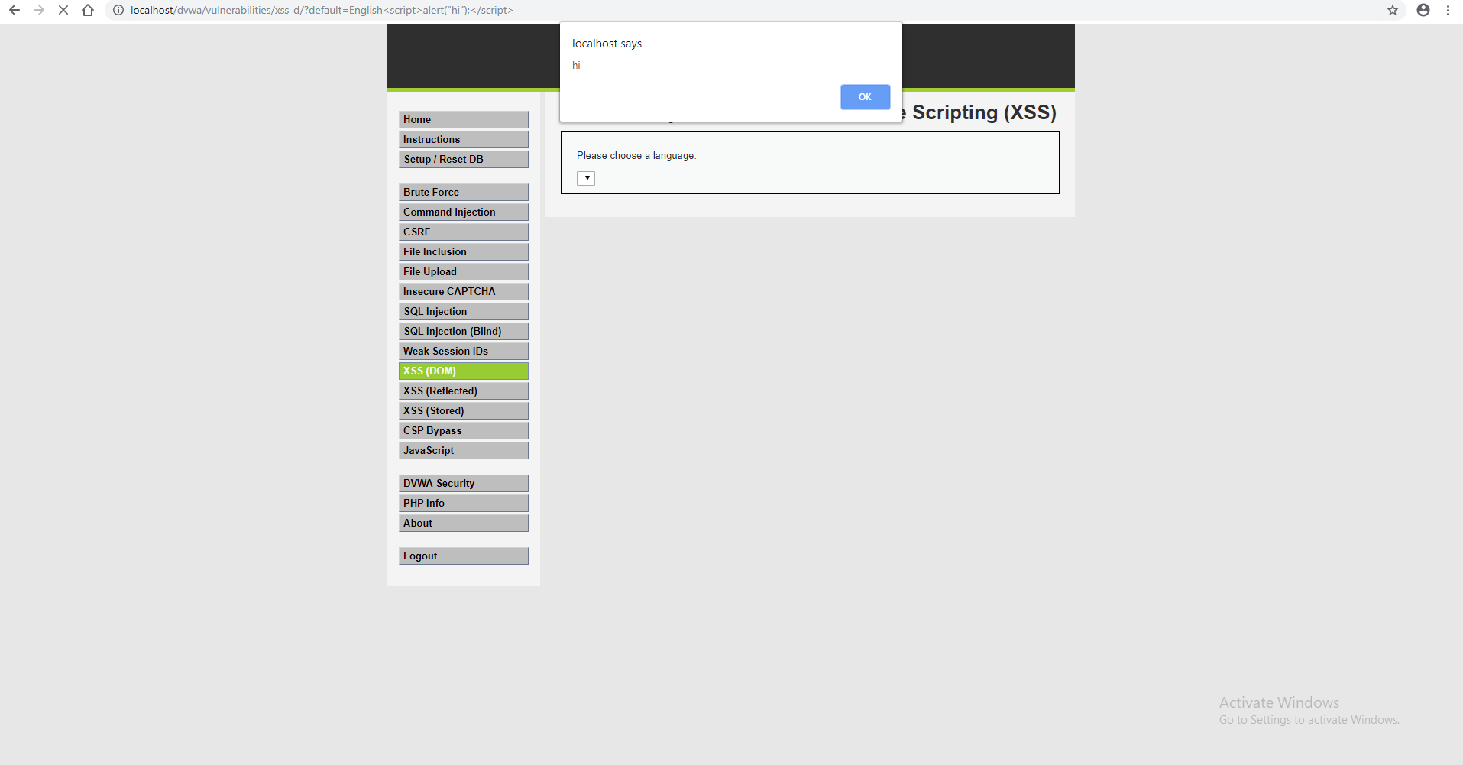

**[2] XSS (Reflected) testing Using DVWA Tool :-**

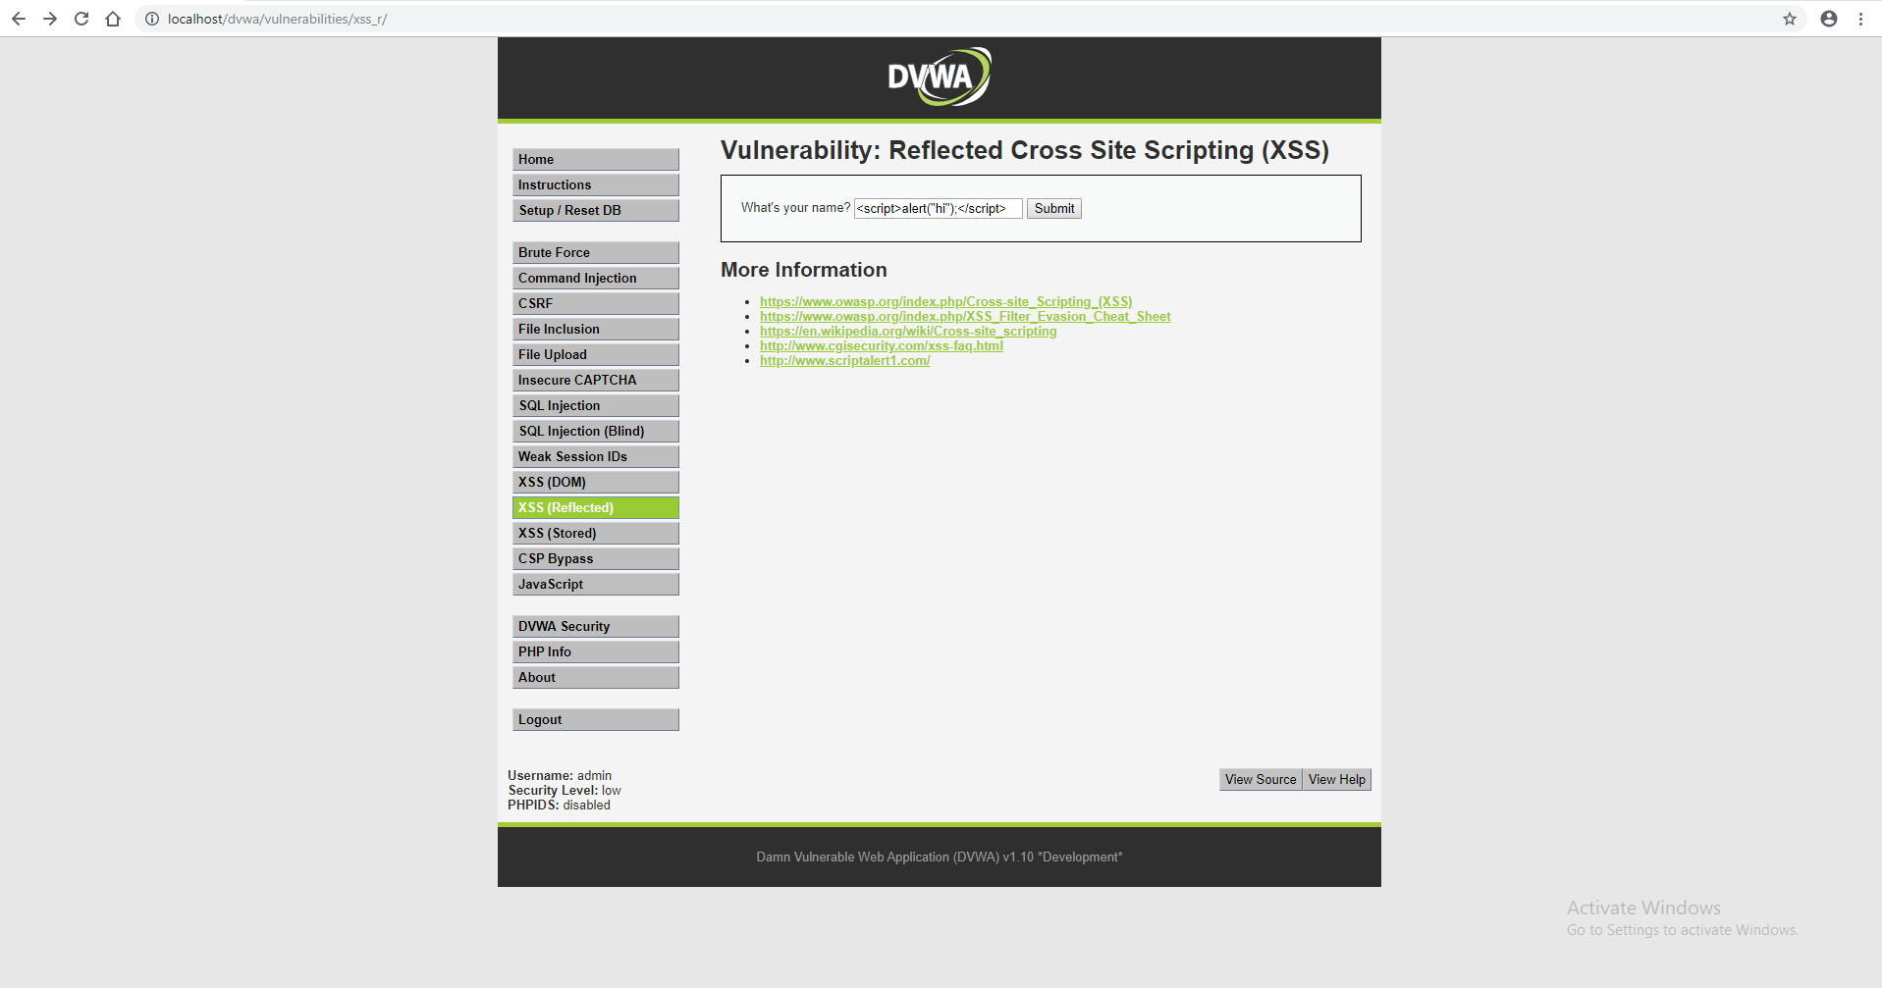Now have a look over a small script which would generate an alert window. So in the given text field for **“name”** I will inject the script in the server.**<script>alert(“hi”)</script>**

The browser will execute our script which generates an alert prompt as showing following screenshot.

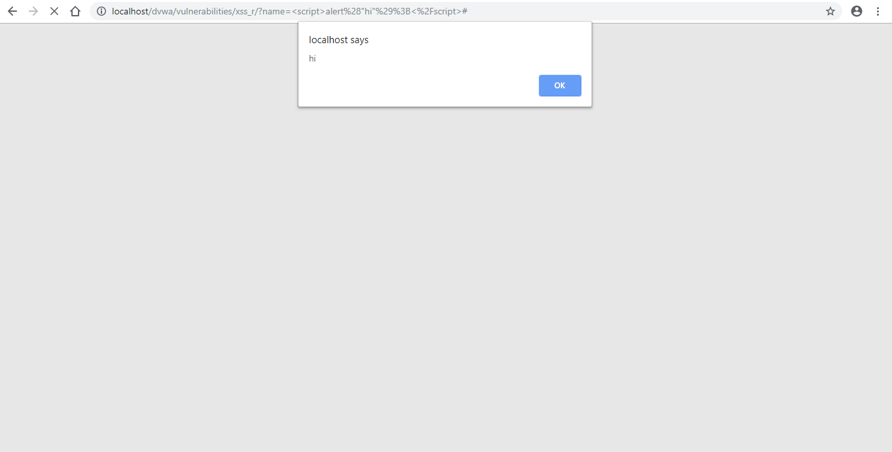In low security, it will easily bypass the injected script when an attacker injects it in the text field given for **“name”** which should be not left empty according to the developer.

**[3] XSS (Stored) testing Using DVWA Tool :-**

Now have a look over a small script which would generate an alert window. So in the text area given for message I will inject the script which gets stored in the server.

**<script>alert(“hi”)</script>**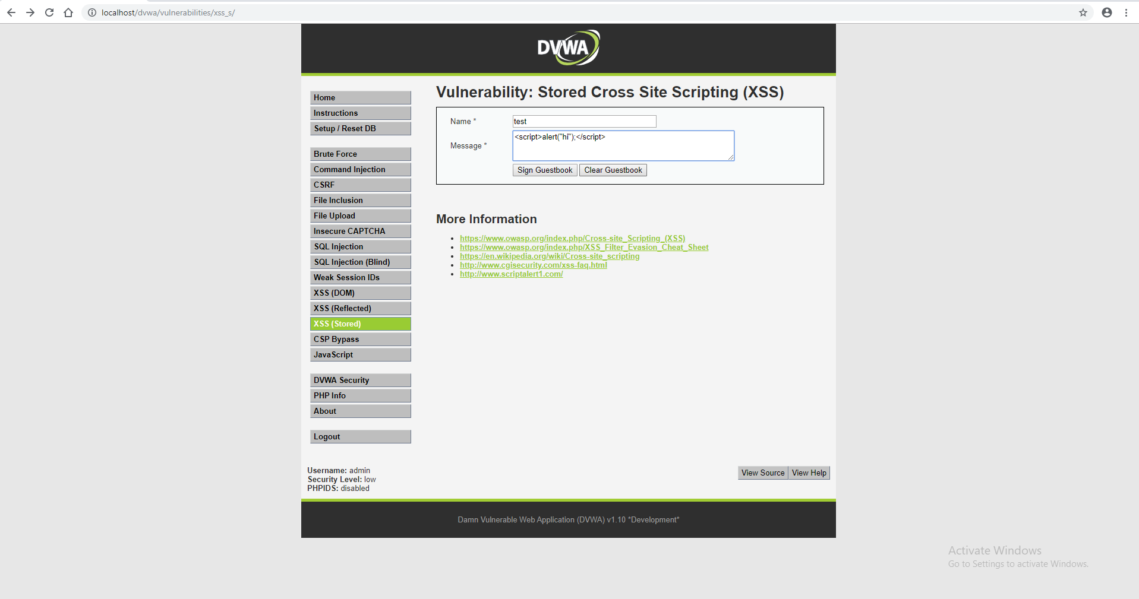

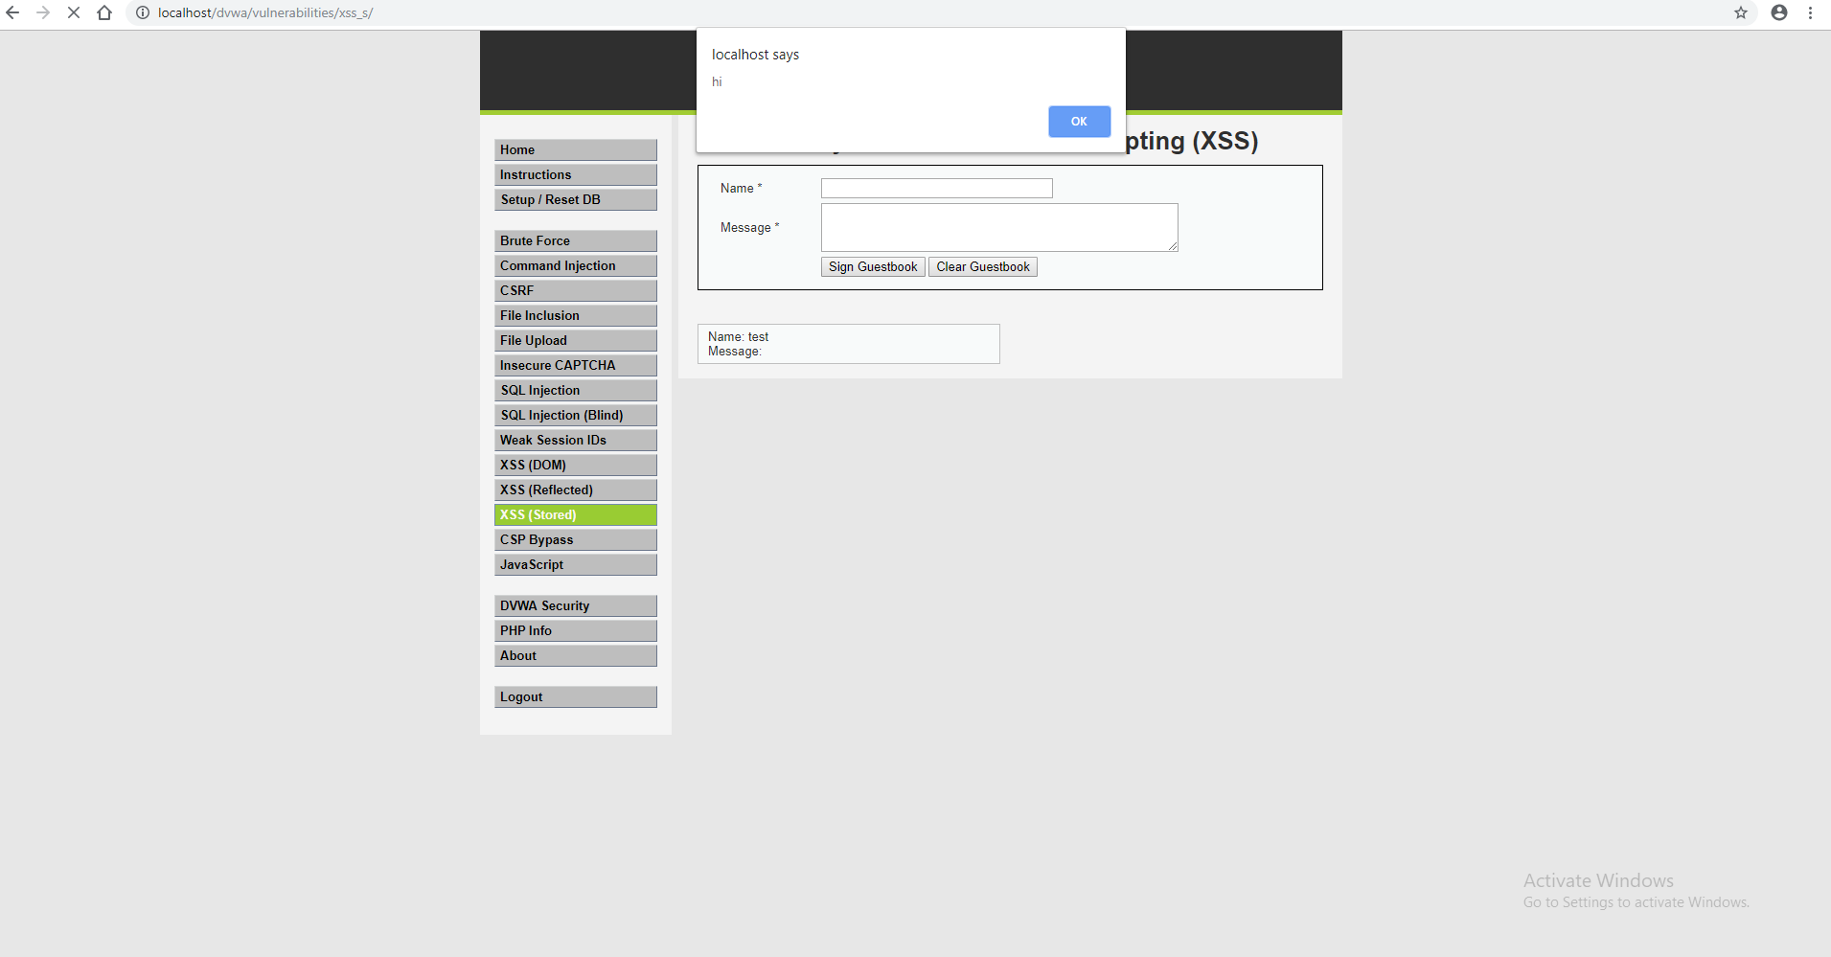Now you can check the output in the given screenshot.

**[4] XSS (Reflected) testing Using DVWA Tool :-**

There are two ways either use <SCRIPT> tag or any other HTML element, right now I had used body tag to inject the string.

**<body onload=alert(“hi”)>**

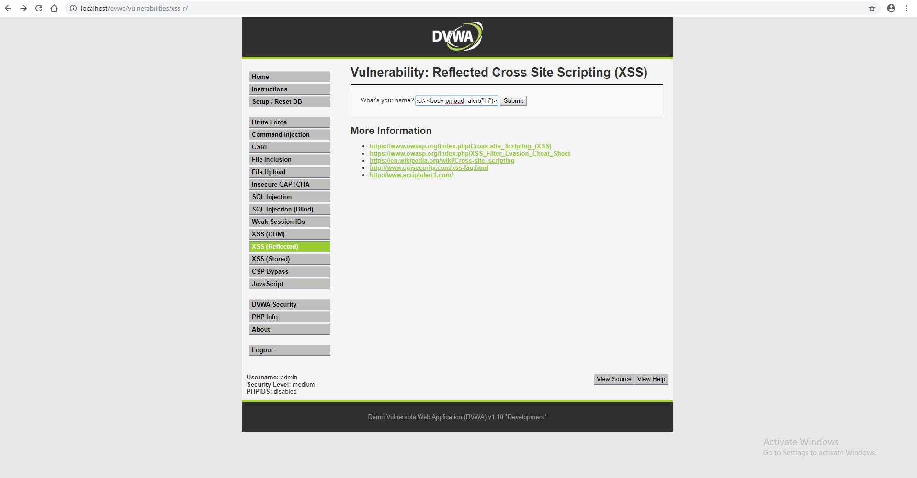

Now you can check the output in the given screenshot.

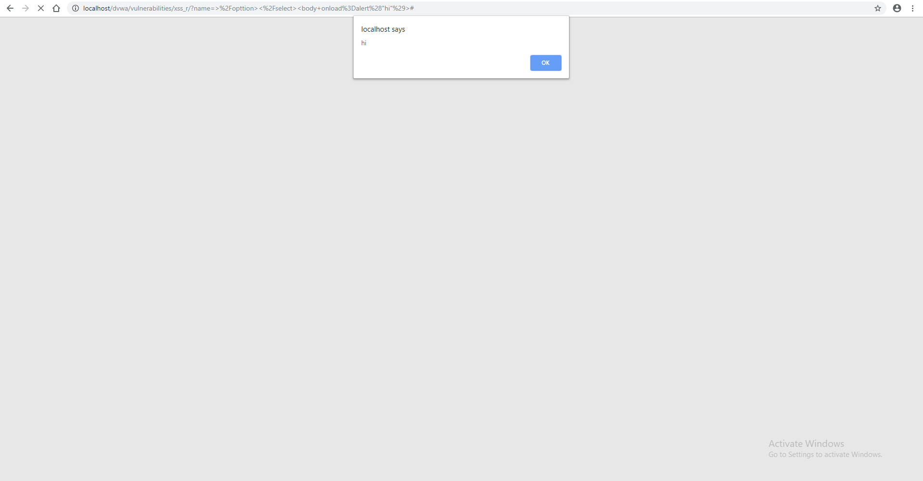

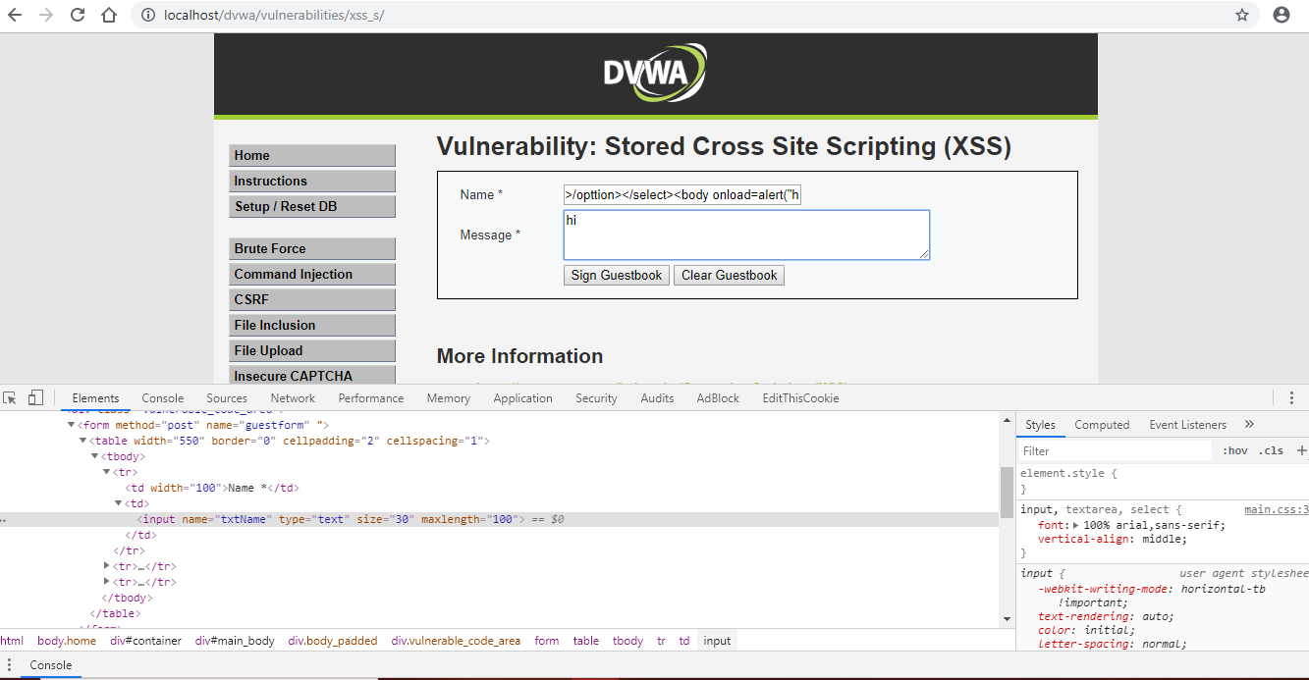[5] **XSS (Stored) testing Using DVWA Tool :-**

Now type following content inside the text field given for “name”.

**<body onload=alert(“hi”)>**

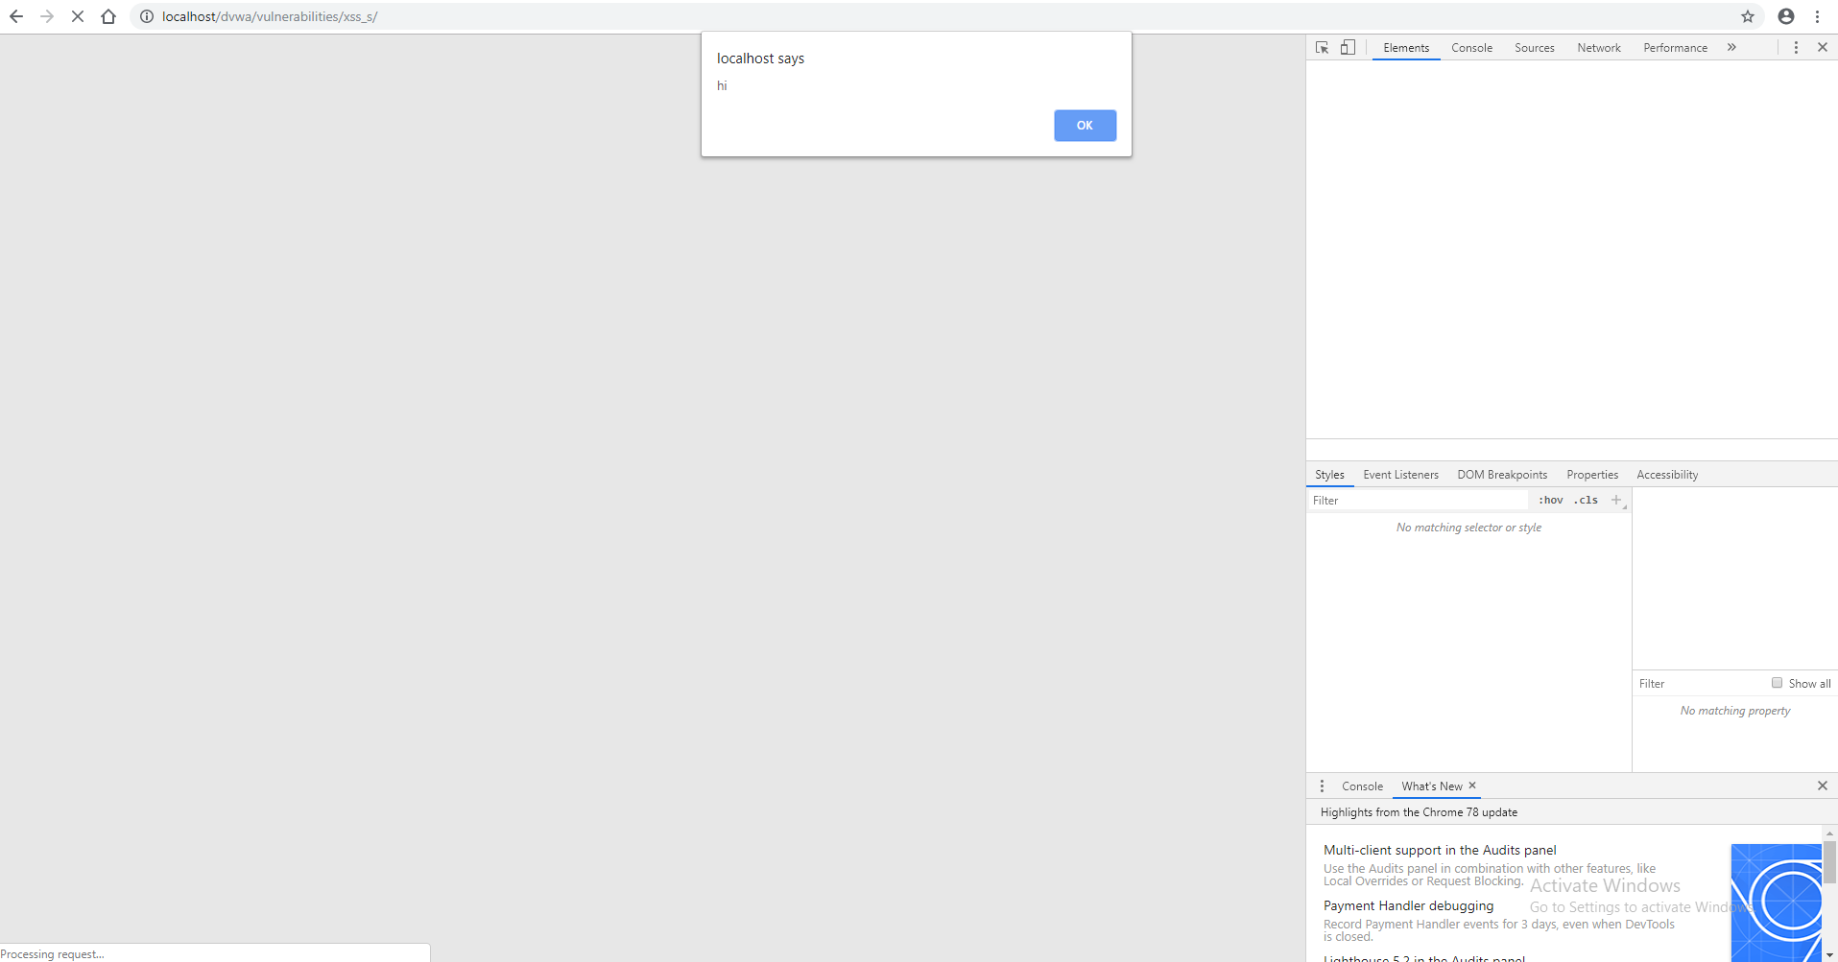Now you can check the output in the given screenshot.[6] **XSS (Reflected) testing Using DVWA Tool :-**

To bypass high-security level use element of HTML, as you can see I have used image source tag to generate the string inside the web server.

**<imgsrc=x onError=”alert(‘The image could not be loaded’ )”>**

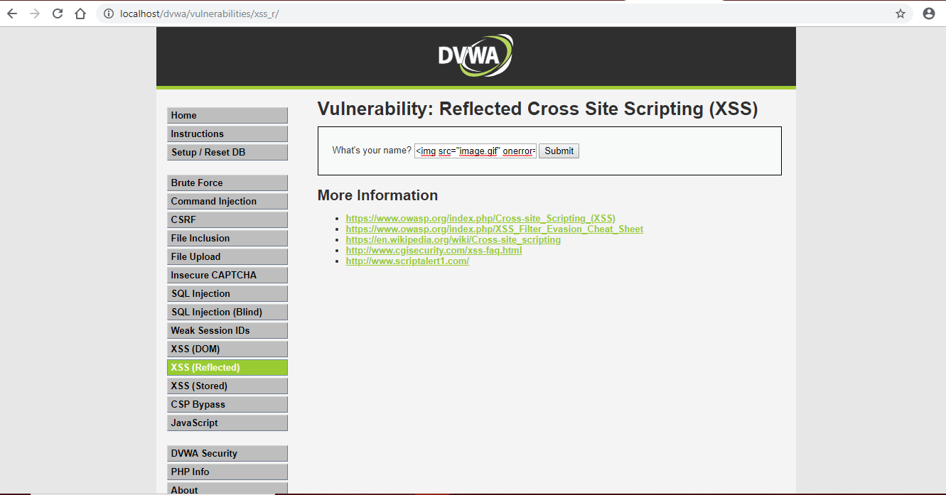

Now you can check the output in the given screenshot.

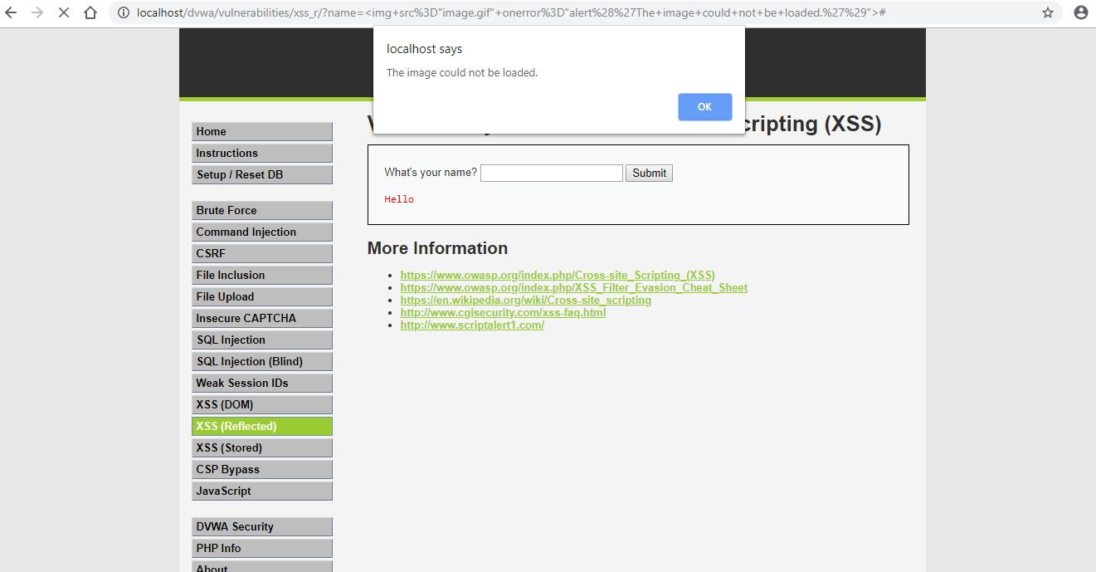

**[7] XSS (Stored) testing Using DVWA Tool :-**

Now type following content inside the text field given for “**name**”.

**<imgsrc=x onError=”alert(‘The image could not be loaded)”>**

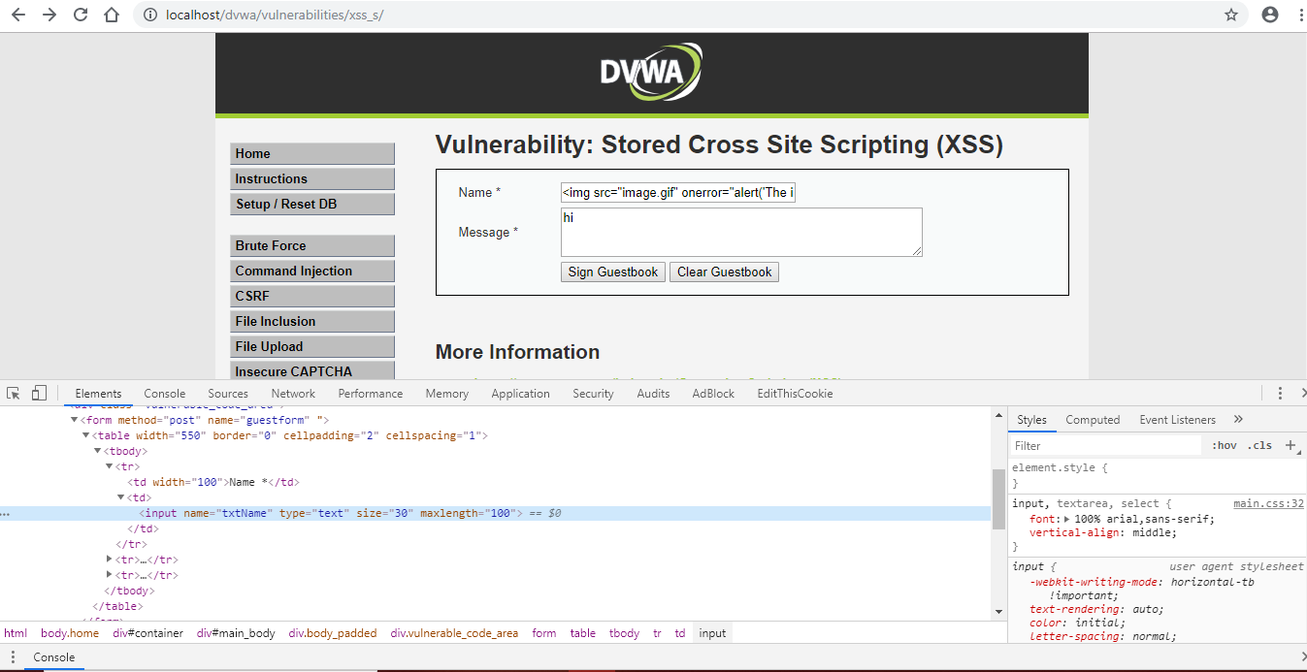

Now you can check the output in the given screenshot.

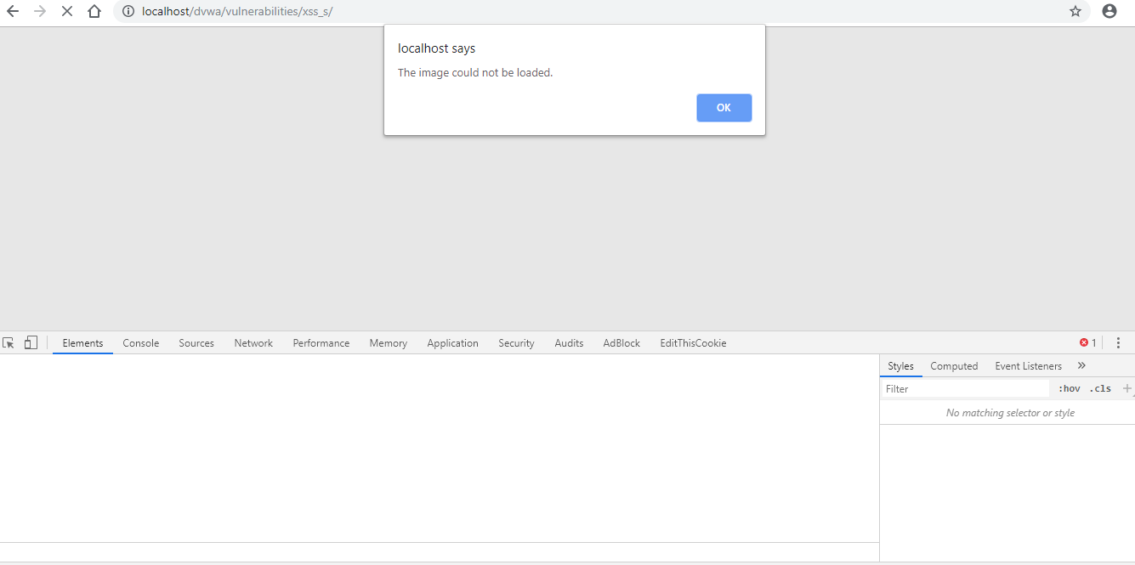

**XSS Flaws**

Cross site Scripting attacks are a type of injection problem, in which malicious scripts are injected into benign and trusted web sites. Cross site scripting flaws are the most common flaw in web applications today. Cross site scripting attacks happen when an attacker uses a web application to send malicious code, normally in the form of a browser side script, to a different end user. Flaws that let these attacks to succeed are quite common and occur anywhere a web application uses input from a user in the output it generates without validating or encoding it.

Attackers commonly use a variety of techniques to encode the malicious portion of the tag, such as using Unicode, so the request is less suspicious looking to the user. There are hundreds of variations of these attacks, involving versions that do not even require any <> symbols. For this reasontrying to filter out these scripts is not likely to succeed. Instead we advise validating input against a rigorous positive specification of what is expected. XSS attacks normally come in the form of embedded JavaScript.

XSS issues can also be present in the main web and application servers as well. Most web and application servers produce simple web pages to display in the case of numerous errors, such as a 500 ‘internal server error.’ Or a 404 ‘page not found’. If these pages reflect back any information from the users request, such as the URL they were trying to gain access, they may be vulnerable to a reflected XSS attack.

The chances that a site contains XSS vulnerabilities is extremely high. There are a wide variety of ways to trick web applications into spreading malicious scripts. Developers that try to filter out the malicious parts of these requests are very likely to overlook possible attacks or encodings. Finding these flaws is not very difficult for attackers, as all they need is a browser and some time. There are many free tools available that help hackers find these flaws as well as carefully craft and inject XSS attacks into a target site.

**Countermeasures**

**11.1 Escaping**

The first method you can use to prevent XSS vulnerabilities from occurring in your applications is by escaping user input. Escaping data means taking the data an application has received and certifying it’s secure before rendering it for the end user. By escaping user input, key characters in the data received by a web page will be banned from being interpreted in any malicious way. In essence, you’resuppressing the data your web page receives in a way that will disallow the characters – especially < and > characters – from being given, which otherwise could cause harm to the application.

 If your page doesn’t allow users to add their own code to the page, a great rule of thumb is to then escape any and all HTML, URL, and JavaScript entities. However, if your web page does allow users to add vivid text, such as on forums or post comments, you have a few options.  You’ll either need to carefully select which HTML entities you will escape and which you won’t, or by using a replacement format for raw HTML such as Markdown, which will in turn allow you to remain escaping all HTML.

**11.2 Validating Input**

Validating input is the procedure of confirming an application is rendering the correct data and preventing malicious data from doing damage to the database, site ,and users. While whitelisting and input validation are more commonly connected with [SQL injection](https://www.checkmarx.com/knowledge/knowledgebase/SQLi), they can also be used as an additional technique of prevention for XSS. Whereas blacklisting, or disallowing certain, predetermined characters in user input, prohibits only known bad characters, whitelisting only permits known good characters and is a better technique for stopping XSS attacks as well as others.

Input validation is especially beneficial and good at preventing XSS in forms, as it prevents a user from adding up special characters into the fields, instead rejecting the request. However, as [OWASP maintains](https://www.owasp.org/index.php/Input_Validation_Cheat_Sheet#White_List_Regular_Expression_Examples),  input validation is not a primary prevention technique for vulnerabilities such as XSS and SQL injection, but instead helps to decrease the effects should an attacker detect such a vulnerability.

**11.3 Sanitizing**

A third way to avoid cross-site scripting attacks is to sanitize user input. Sanitizing data is a strong defence, but should not be used alone to fight XSS attacks. It’s completely possible you’ll find the need to use all three techniques of prevention in working towards a more secure application. Sanitizing user input is especially helpful on sites that allow HTML markup, to make sure data received can do no harm to users as well as your database by scrubbing the data clean of possibly harmful markup, changing unacceptable user input to an acceptable format.

**Conclusion**

1. SQL Injection is an attack which basically targets the data present in the databases to gain the unauthorized access of any websites or to gain the confidential information about the users.
2. To prevent the SQL Injection we must follows this listed rules:-
3. Never build dynamic SQL statement directly from the user input and never concatenate user input with SQL statements, which is not validated at the server level.
4. Privileges of the user accounts used in the application for executing SQL statements on the database must be least to complete that particular task.
5. Length of the user input should be limited.
6. Delete characters like slash, backslash, extended characters like NULL, carry return, new line in all strings from user input and parameters from URL.
7. Reject input that contains potentially dangerous characters such as ( ; ) which means query delimiter ( ‘ ) which means character data string delimiter and ( -- ) which means single line comment.
8. Cross-site scripting is one of the most hazardous and most common website vulnerability on the internet.
9. An XSS attack comes in various forms that range from something as small as pop up in a window, to something as harmful as a virus or a worm, and even worse; XSS is capable of compromising a person’s identity.
10. Nobody in this world is ever completely safe from it. As XSS vulnerabilities continue to grow, the best way to protect yourself against it is to always be on the alert, and be aware of what you should do when you come across it.

**Reference**

**[1]**<https://www.esecurityplanet.com/threats/how-to-prevent-sql-injection-attacks.html>

**[2]** <https://www.optiv.com/blog/sql-injection-and-reflected-content-sniffing-attacks>

**[3]** <https://medium.com/tech-zoom/dirb-a-web-content-scanner-bc9cba624c86>

**[4]** <https://www.synopsys.com/software-integrity/resources/knowledge-database/sql-injection.html>

**[5]**<http://en.wikipedia.org/wiki/Cross-site_scripting>

**[6]** <http://www.cgisecurity.com/articles/xss-faq.shtml>

**[7]** <http://www.owasp.org/index.php/Top_10_2007-A1>

**[8]** <http://www.ibm.com/developerworks/tivoli/library/s-csscript/>

**[9]**<http://www.owasp.org/index.php/Cross-site-scripting>

**[10]**http://shiflett.org/articles/foiling-cross-site-attacks